Rotational Symmetry

Definition
# Source: AI Source: Provided by: [Data Path: Persons Table -> ID Column: 1, Name_En Column: Motasem Essam] -> From: [ChatGPT] on [7/25/2026]
Rotational Symmetry is a type of geometric symmetry in which a figure can be rotated about a fixed point by an angle less than ${360}^{∘}$ and still coincide exactly with its original position.
The fixed point is called the center of rotation.
A figure has rotational symmetry when it looks the same after one or more rotations during a complete ${360}^{∘}$ turn.
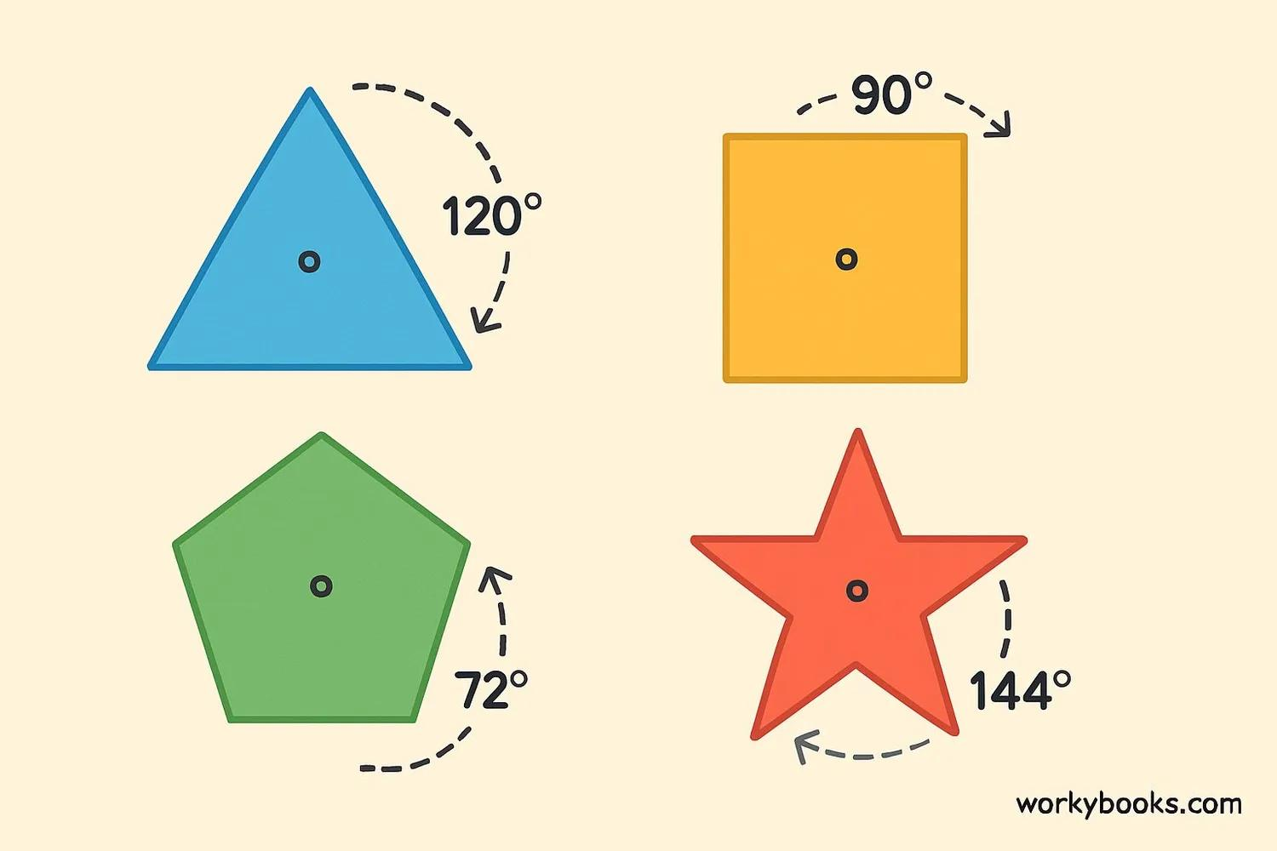
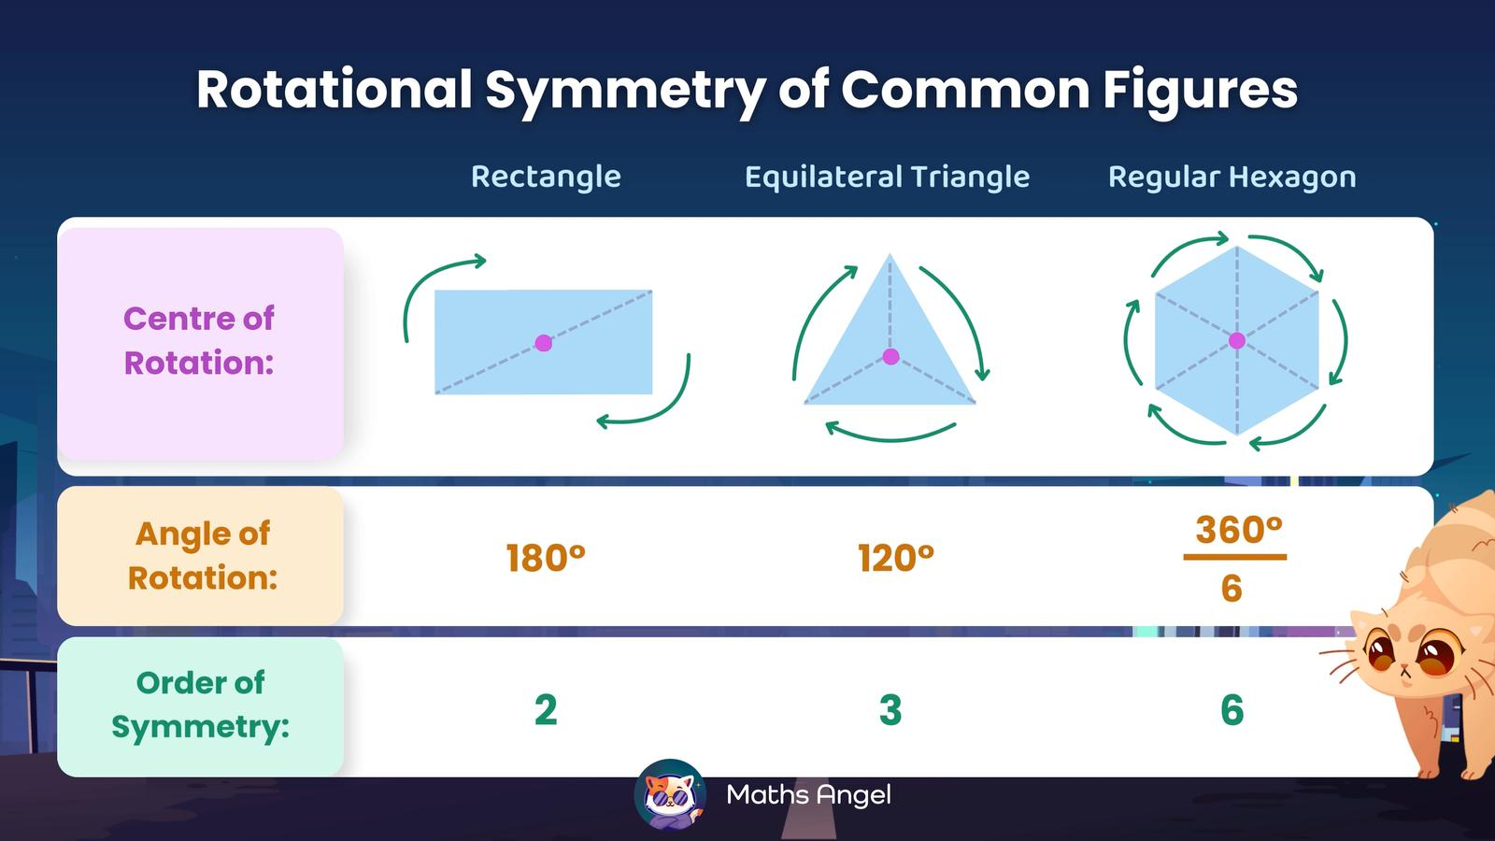
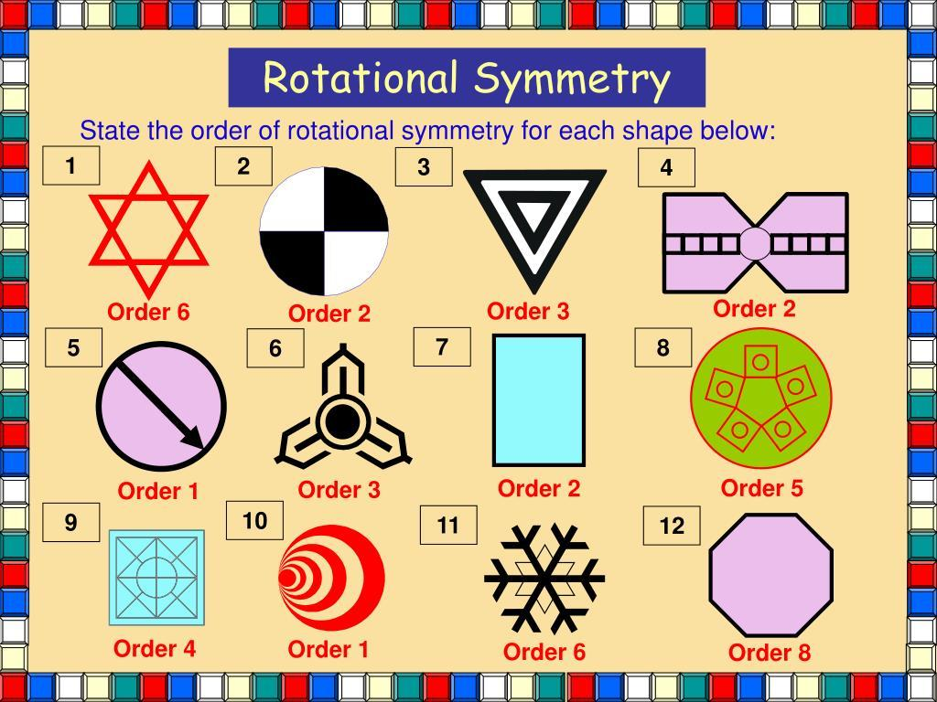
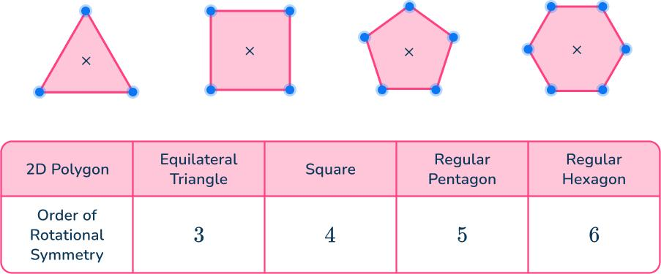
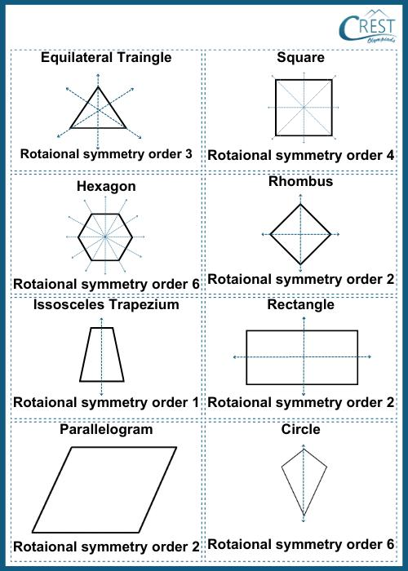

Purpose
# Source: AI Source: Provided by: [Data Path: Persons Table -> ID Column: 1, Name_En Column: Motasem Essam] -> From: [ChatGPT] on [7/25/2026]
Rotational symmetry is used to:
- Identify figures that repeat around a central point.
- Determine the number of times a figure matches itself during one complete rotation.
- Analyze geometric patterns.
- Understand rotations and geometric transformations.
- Study regular polygons.
- Create rotationally balanced designs.
- Analyze objects in engineering and architecture.
- Support computer graphics and modeling.

Fundamental Idea
# Source: AI Source: Provided by: [Data Path: Persons Table -> ID Column: 1, Name_En Column: Motasem Essam] -> From: [ChatGPT] on [7/25/2026]
A figure has rotational symmetry if rotating it around a fixed center produces the same figure before completing a full ${360}^{∘}$ rotation.
For example, a square can be rotated by:
$${90}^{∘}$$
and still look exactly the same.
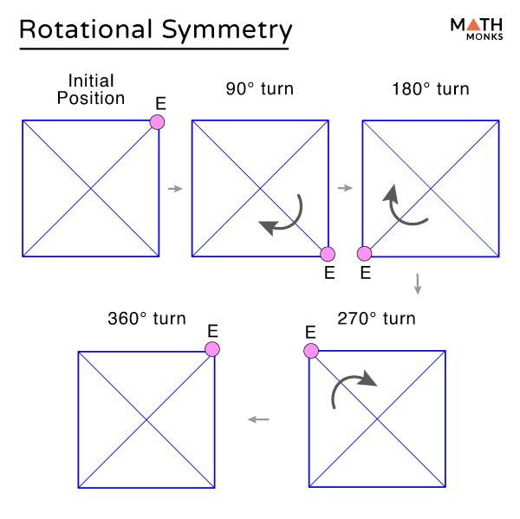
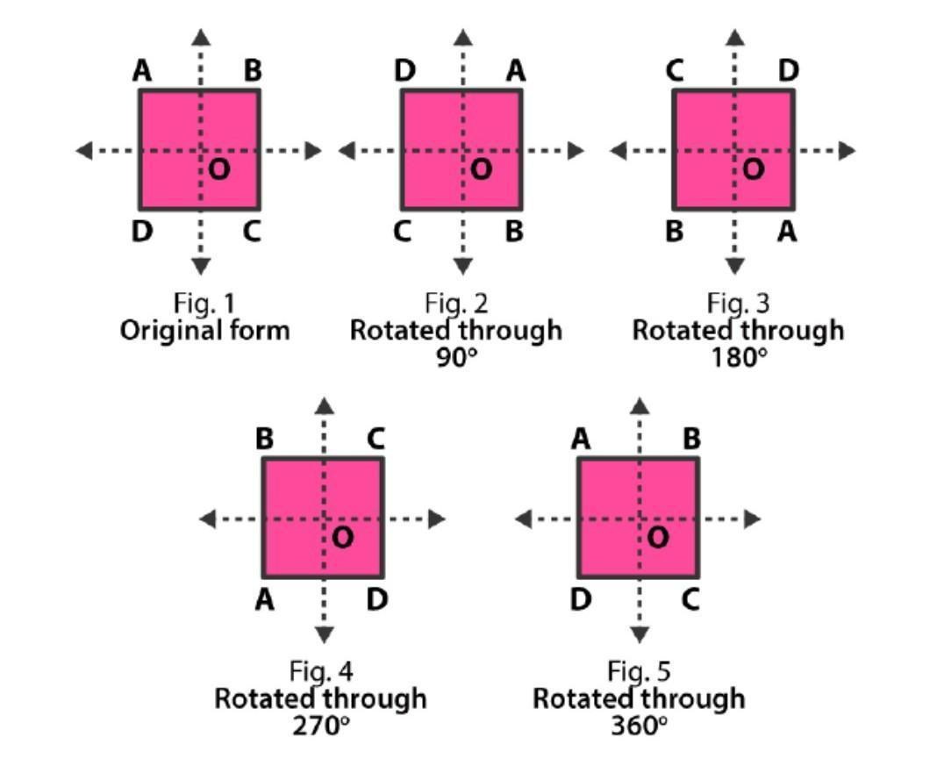
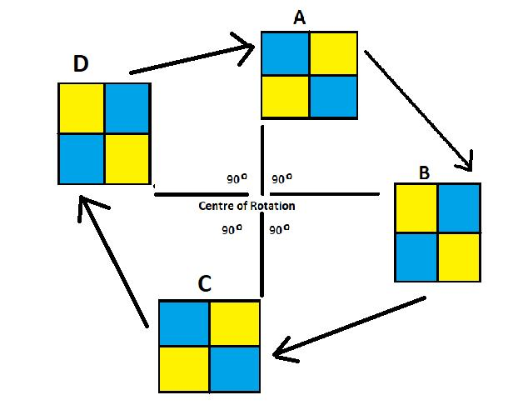
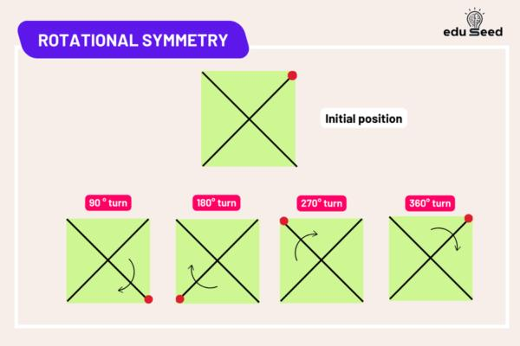
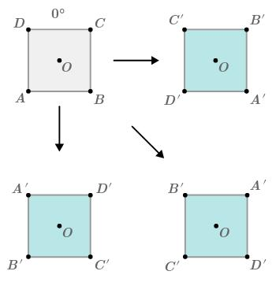
Therefore, a square has rotational symmetry.

Center of Rotation
# Source: AI Source: Provided by: [Data Path: Persons Table -> ID Column: 1, Name_En Column: Motasem Essam] -> From: [ChatGPT] on [7/25/2026]
Definition
The center of rotation is the fixed point around which the figure rotates.
For a regular polygon, the center of rotation is usually its geometric center.
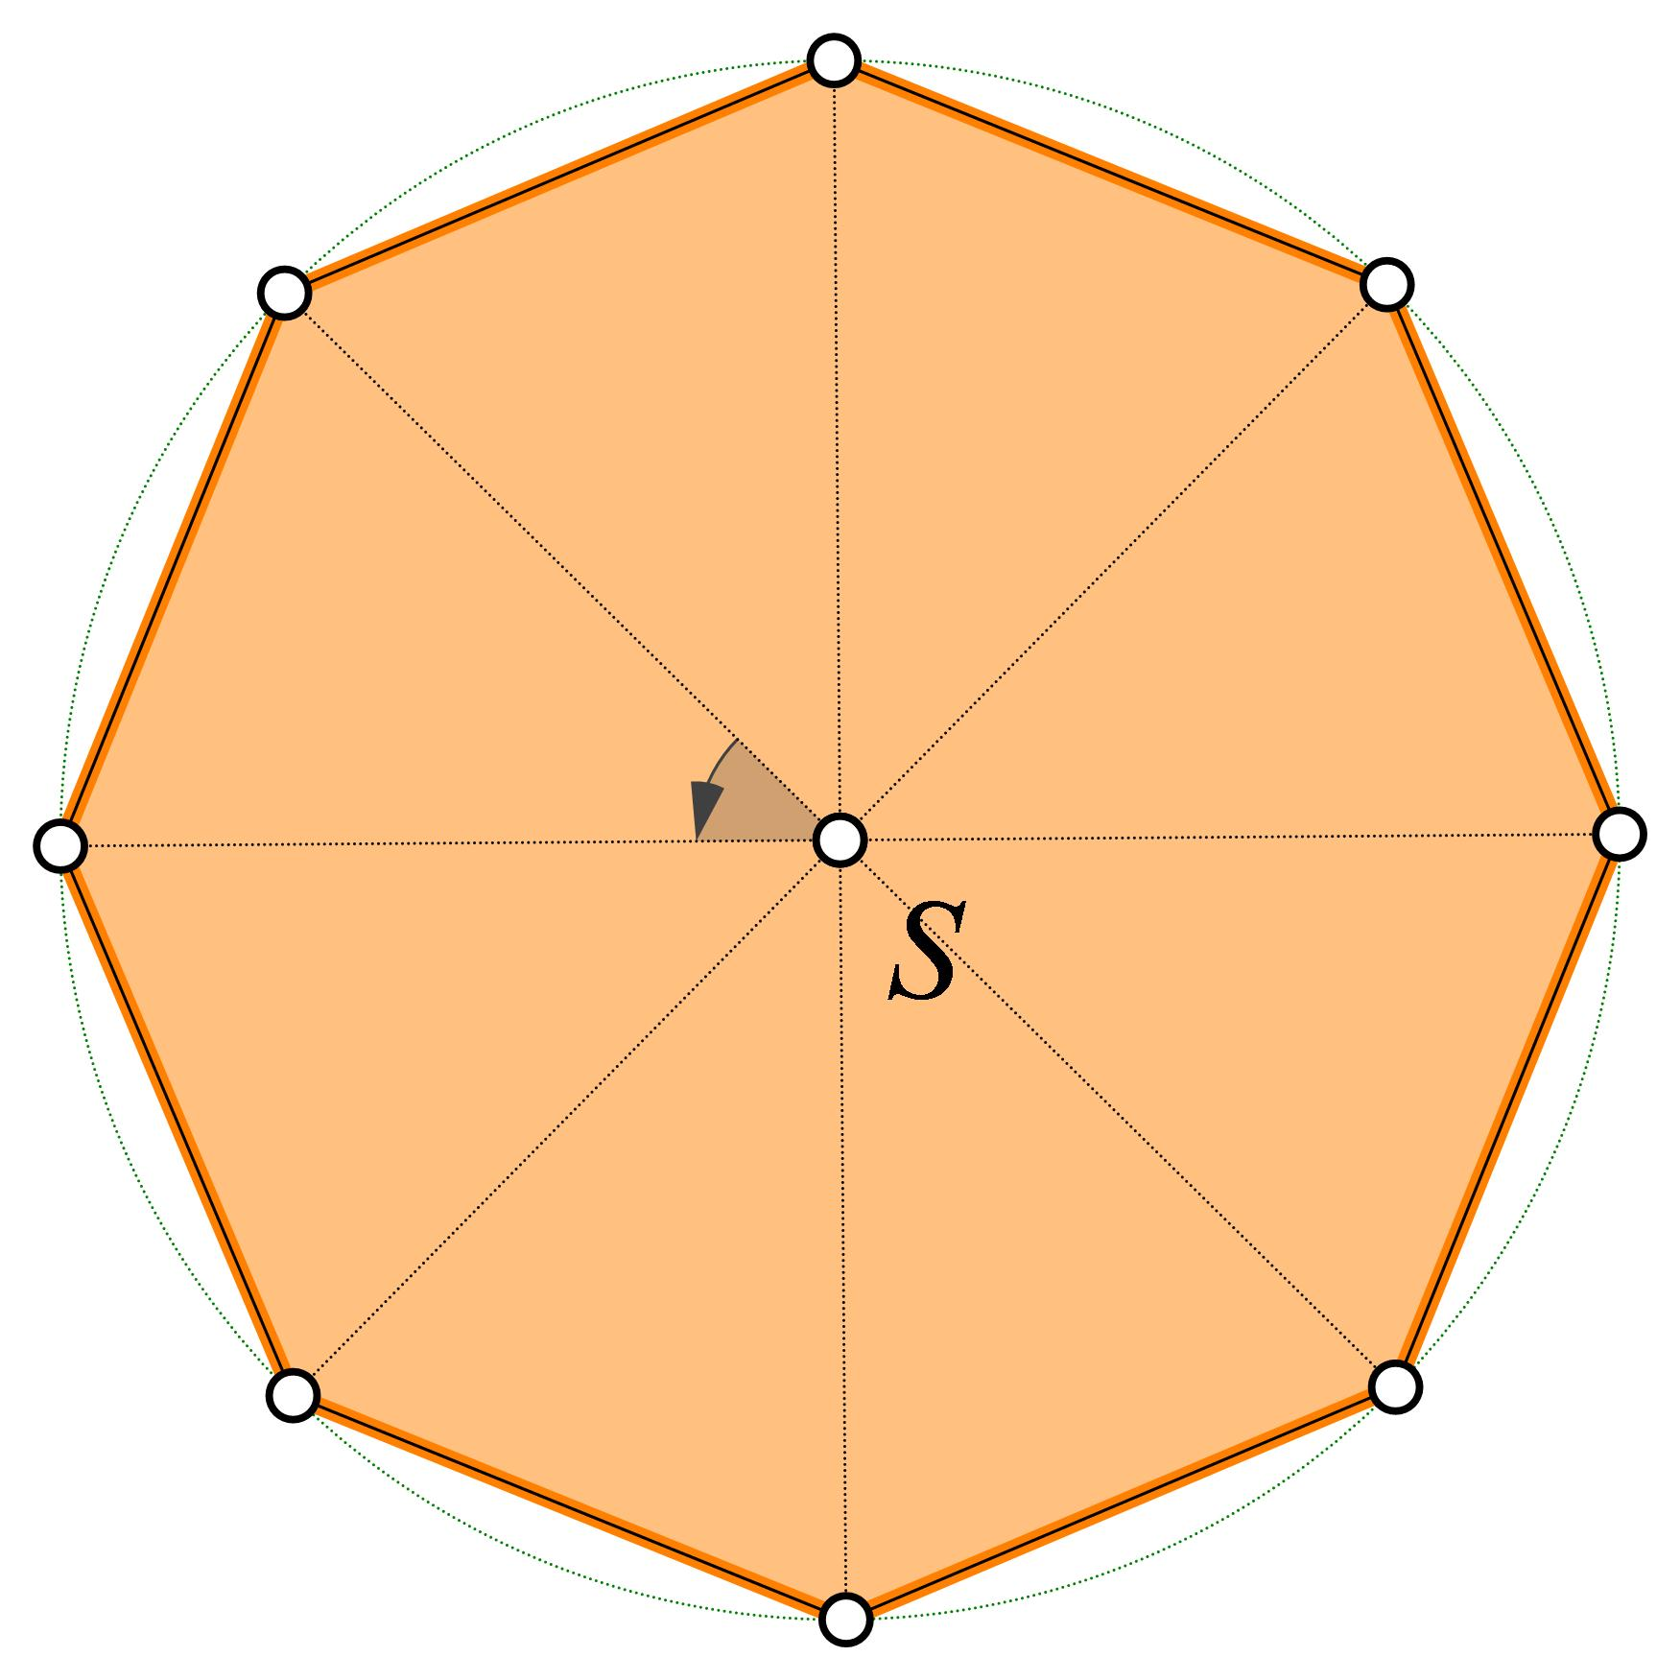
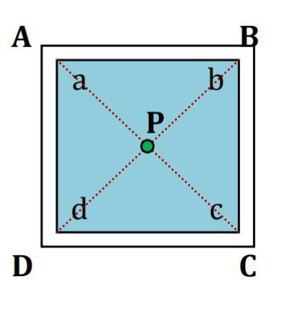
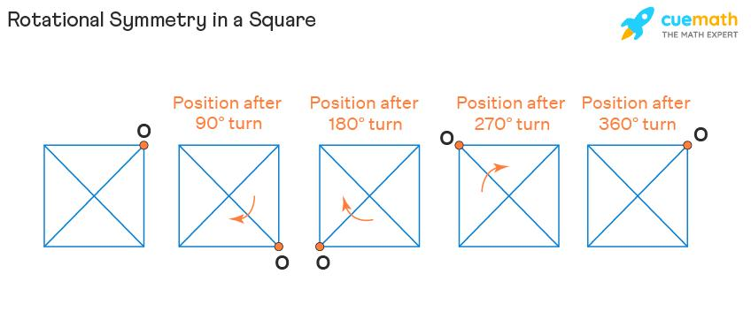
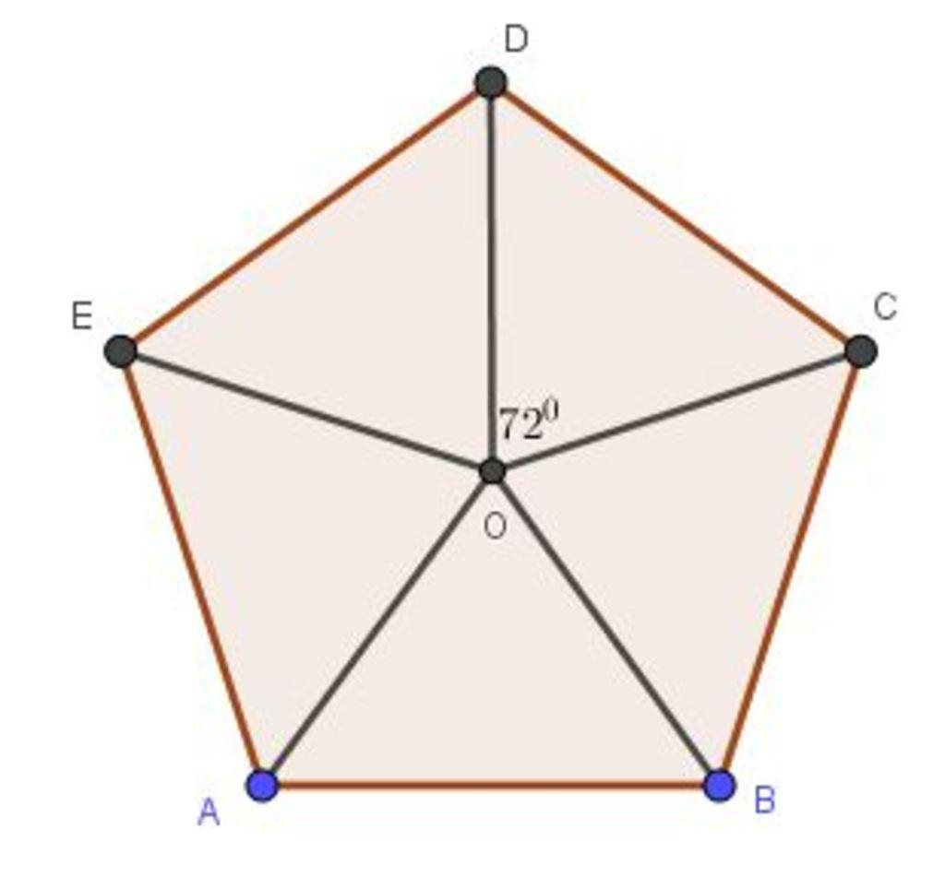
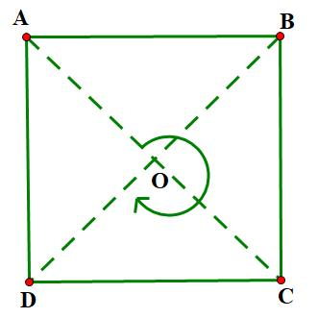
During the rotation:
- The center remains fixed.
- Every other point moves around the center.
- Distances from the center remain unchanged.

Order of Rotational Symmetry
# Source: AI Source: Provided by: [Data Path: Persons Table -> ID Column: 1, Name_En Column: Motasem Essam] -> From: [ChatGPT] on [7/25/2026]
Definition
The order of rotational symmetry is the number of times a figure coincides with itself during one complete ${360}^{∘}$ rotation.
It is usually denoted by:
$$\boxed{n}$$
For example, a square matches itself four times during one complete rotation:
$$0^{∘}, {90}^{∘}, {180}^{∘}, {270}^{∘}$$
Therefore:
$$\boxed{\text{Order}=4}$$
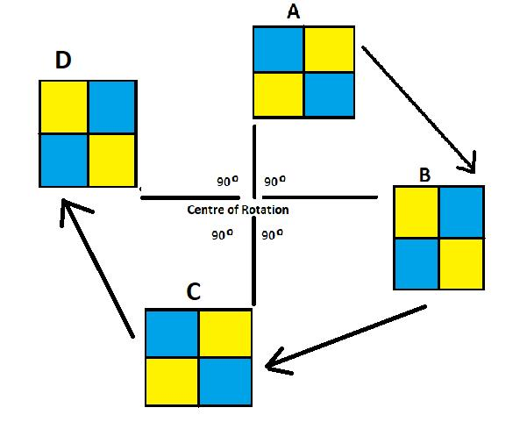
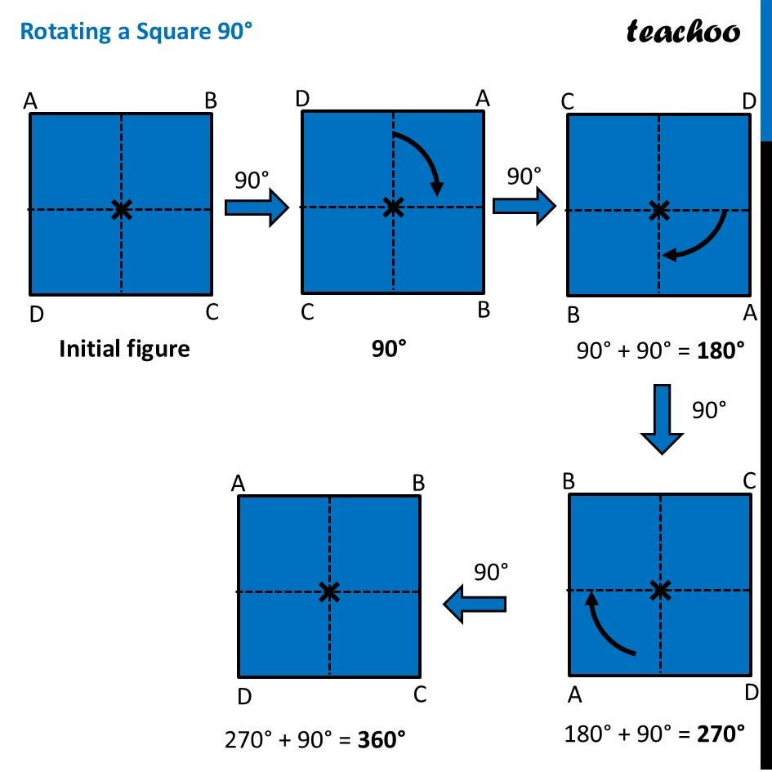

Smallest Angle of Rotational Symmetry
# Source: AI Source: Provided by: [Data Path: Persons Table -> ID Column: 1, Name_En Column: Motasem Essam] -> From: [ChatGPT] on [7/25/2026]
For a figure with rotational symmetry of order $n$, the smallest positive angle of rotation is:
$$\boxed{θ=\frac{{360}^{∘}}{n}}$$
where:
- $θ$ = smallest angle of rotation.
- $n$ = order of rotational symmetry.
Example: Square
A square has:
$$n=4$$
Therefore:
$$θ=\frac{{360}^{∘}}{4} \\ \boxed{θ={90}^{∘}}$$

Examples of Rotational Symmetry

Equilateral Triangle
# Source: AI Source: Provided by: [Data Path: Persons Table -> ID Column: 1, Name_En Column: Motasem Essam] -> From: [ChatGPT] on [7/25/2026]
An equilateral triangle has rotational symmetry of order:
$$\boxed{3}$$
The smallest rotation is:
$$\frac{{360}^{∘}}{3}={120}^{∘}$$
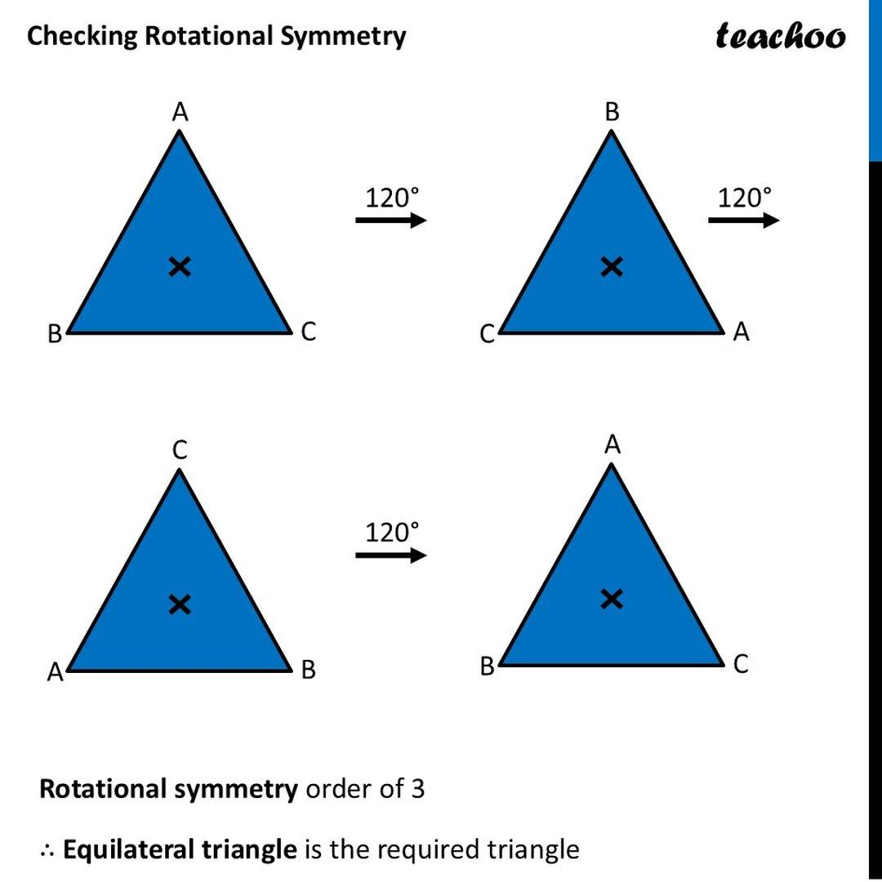
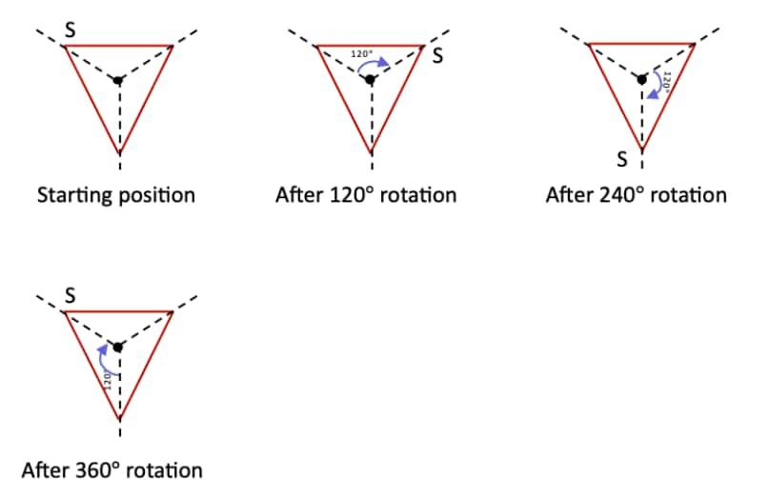
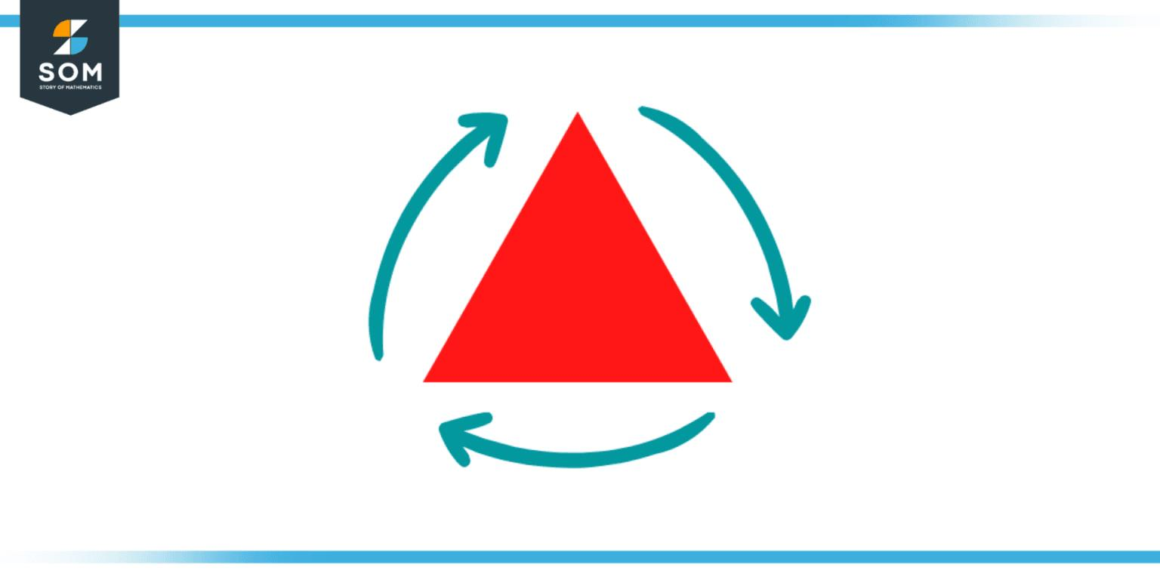
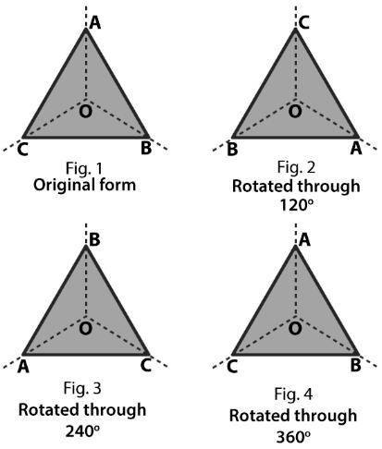
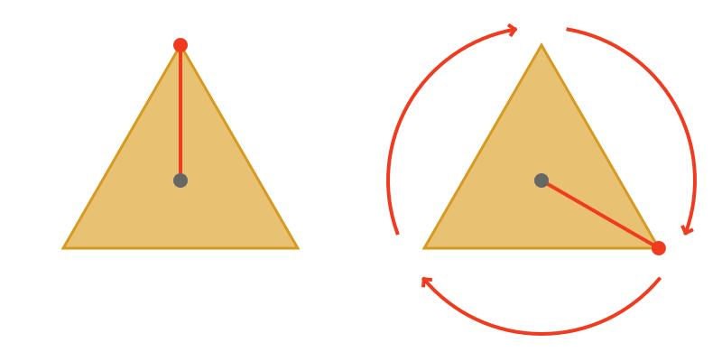

Square
# Source: AI Source: Provided by: [Data Path: Persons Table -> ID Column: 1, Name_En Column: Motasem Essam] -> From: [ChatGPT] on [7/25/2026]
A square has:
$$\boxed{4}$$
orders of rotational symmetry.
The smallest rotation is:
$$\frac{{360}^{∘}}{4}={90}^{∘}$$
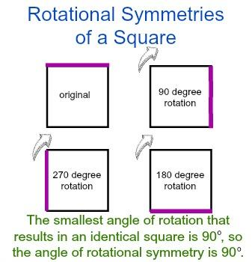

Regular Pentagon
# Source: AI Source: Provided by: [Data Path: Persons Table -> ID Column: 1, Name_En Column: Motasem Essam] -> From: [ChatGPT] on [7/25/2026]
A regular pentagon has:
$$\boxed{5}$$
orders of rotational symmetry.
The smallest rotation is:
$$\frac{{360}^{∘}}{5}={72}^{∘}$$
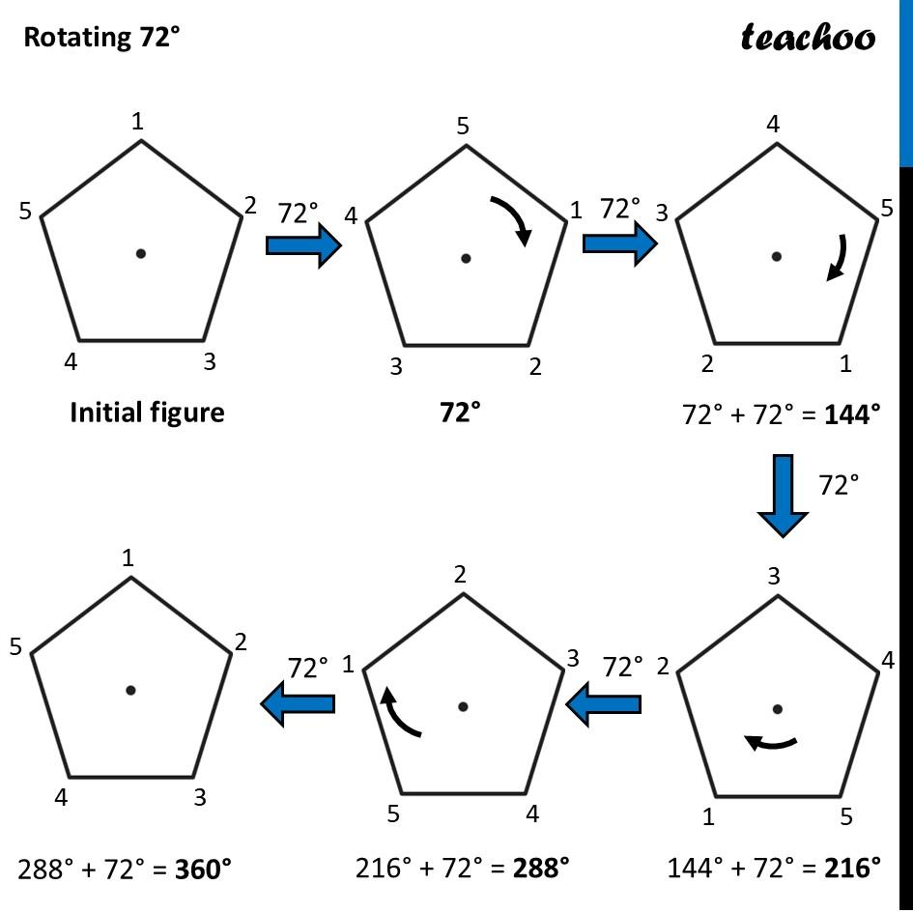
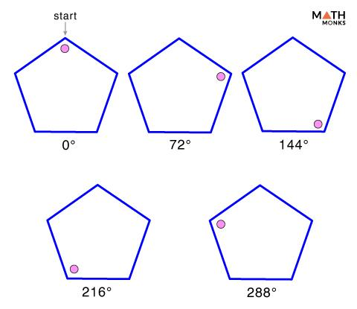
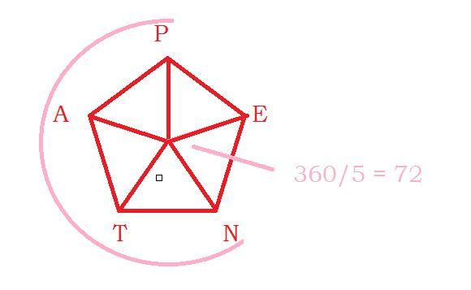
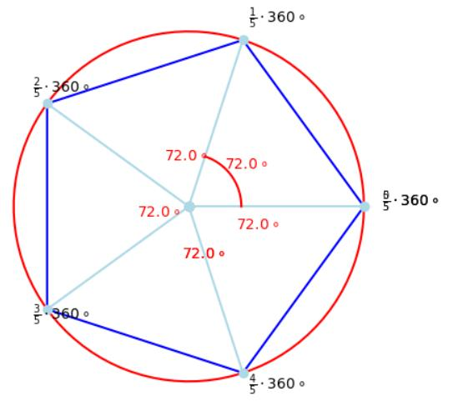
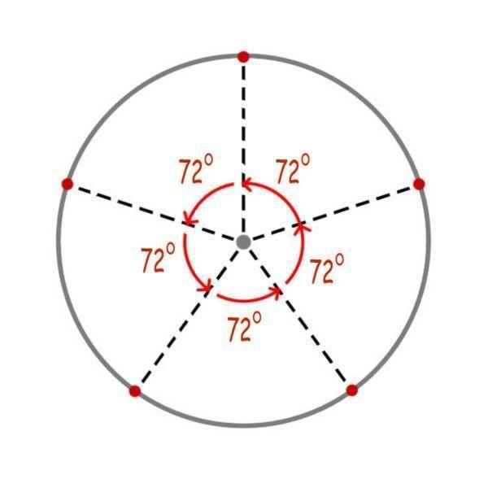

Regular Hexagon
# Source: AI Source: Provided by: [Data Path: Persons Table -> ID Column: 1, Name_En Column: Motasem Essam] -> From: [ChatGPT] on [7/25/2026]
A regular hexagon has:
$$\boxed{6}$$
orders of rotational symmetry.
The smallest rotation is:
$$\frac{{360}^{∘}}{6}={60}^{∘}$$
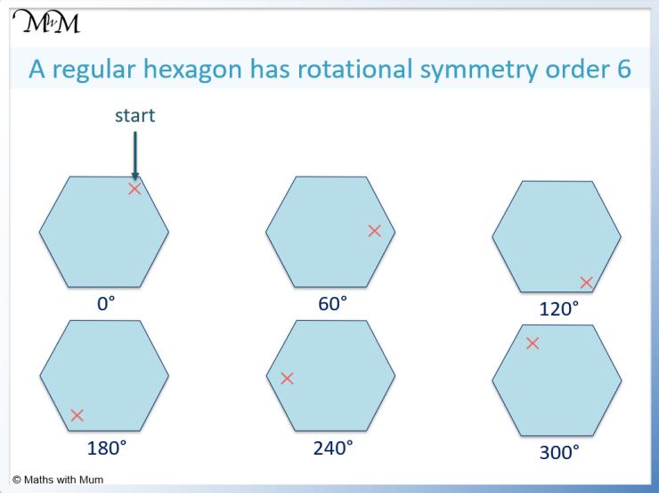
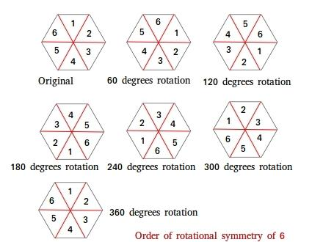
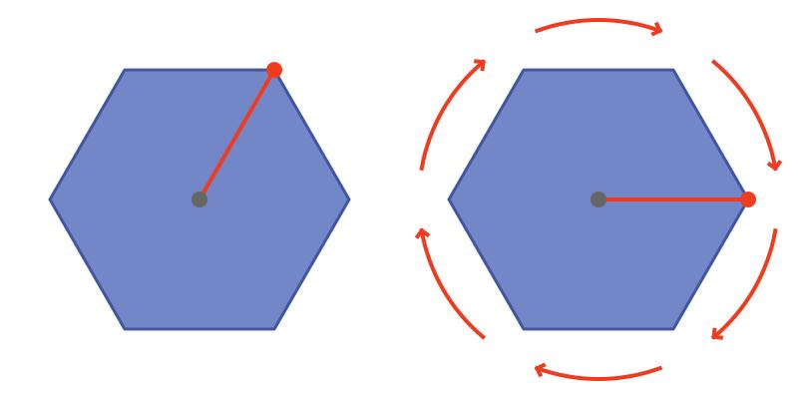
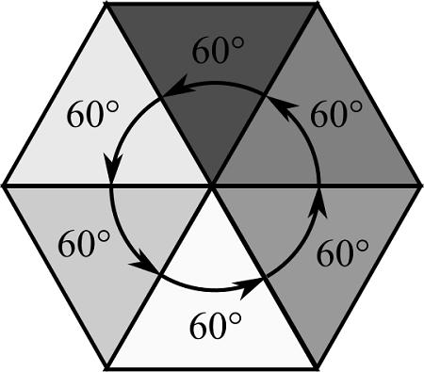
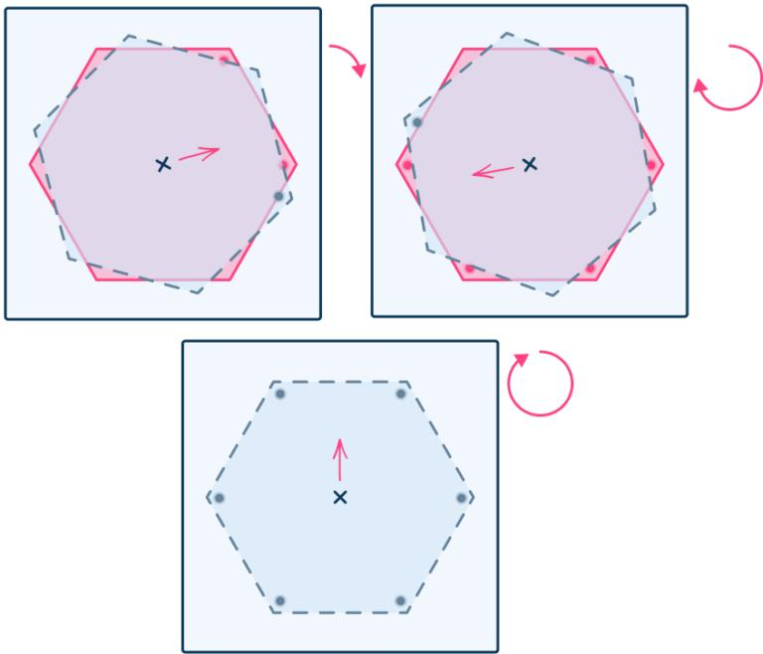

Regular Polygons
# Source: AI Source: Provided by: [Data Path: Persons Table -> ID Column: 1, Name_En Column: Motasem Essam] -> From: [ChatGPT] on [7/25/2026]
A regular polygon with $n$ sides has rotational symmetry of order:
$$\boxed{n}$$
Therefore:
$$\boxed{\text{Order of rotational symmetry}=\text{number of sides}}$$
and the smallest angle is:
$$\boxed{θ=\frac{{360}^{∘}}{n}}$$
Regular Polygon | Sides | Order | Smallest Angle
Equilateral Triangle | $$3$$ | $$3$$ | $${120}^{∘}$$
Square | $$4$$ | $$4$$ | $${90}^{∘}$$
Regular Pentagon | $$5$$ | $$5$$ | $${72}^{∘}$$
Regular Hexagon | $$6$$ | $$6$$ | $${60}^{∘}$$
Regular Heptagon | $$7$$ | $$7$$ | $$≈{51.43}^{∘}$$
Regular Octagon | $$8$$ | $$8$$ | $${45}^{∘}$$
Regular Decagon | $$10$$ | $$10$$ | $${36}^{∘}$$
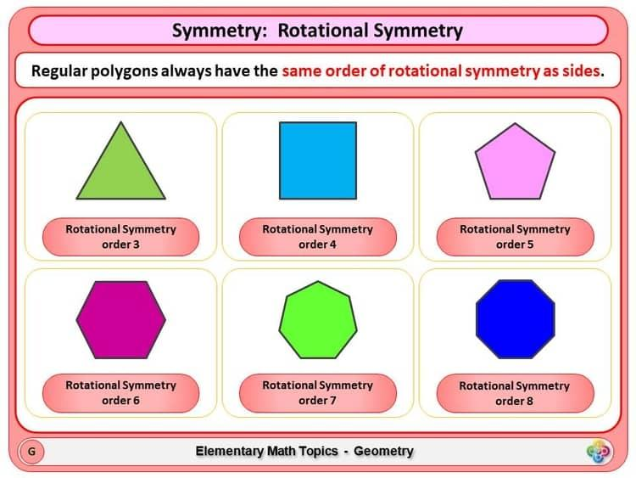
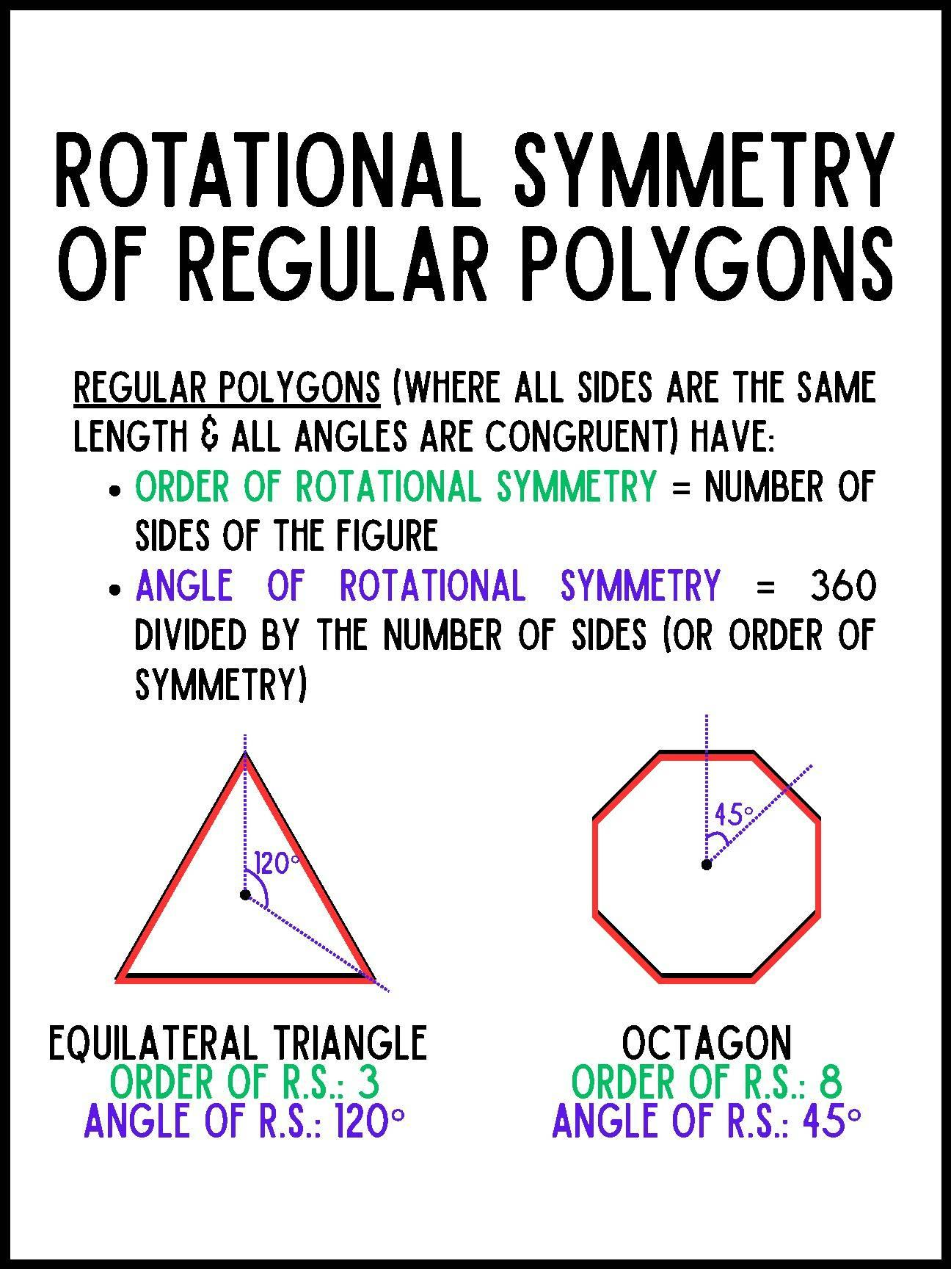
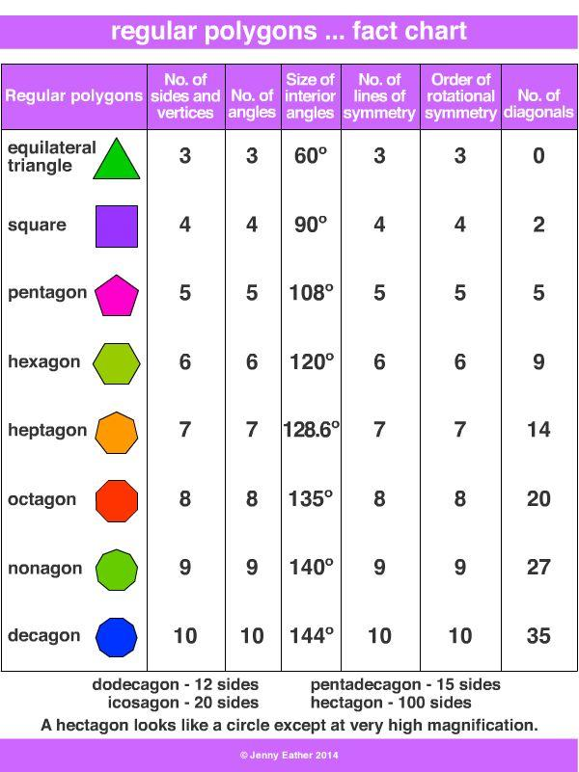

Circle
# Source: AI Source: Provided by: [Data Path: Persons Table -> ID Column: 1, Name_En Column: Motasem Essam] -> From: [ChatGPT] on [7/25/2026]
A circle has infinite rotational symmetry.
It looks exactly the same after rotation through any angle about its center.
$$\boxed{\text{Order}=∞}$$
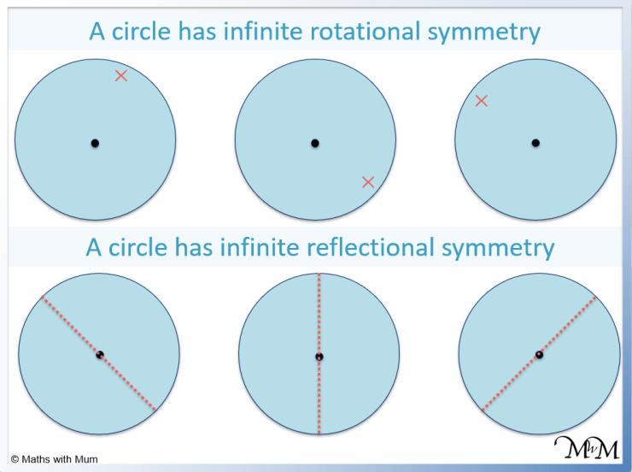
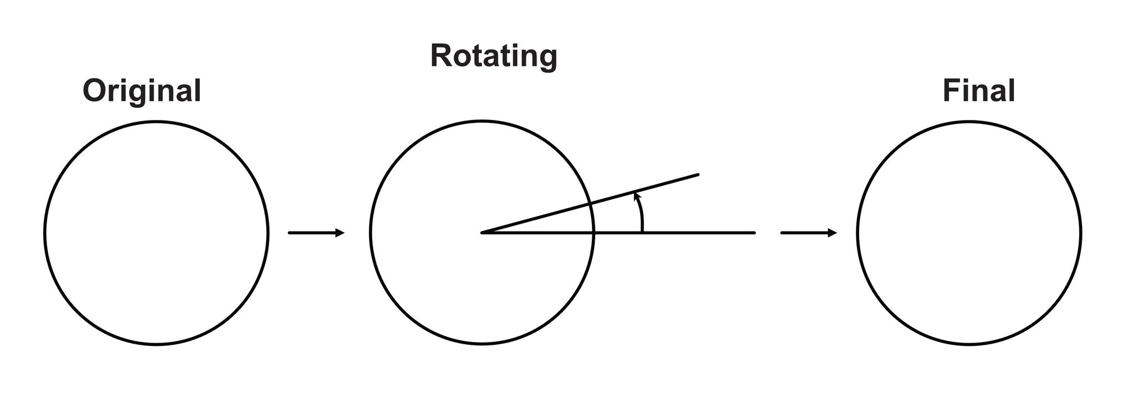
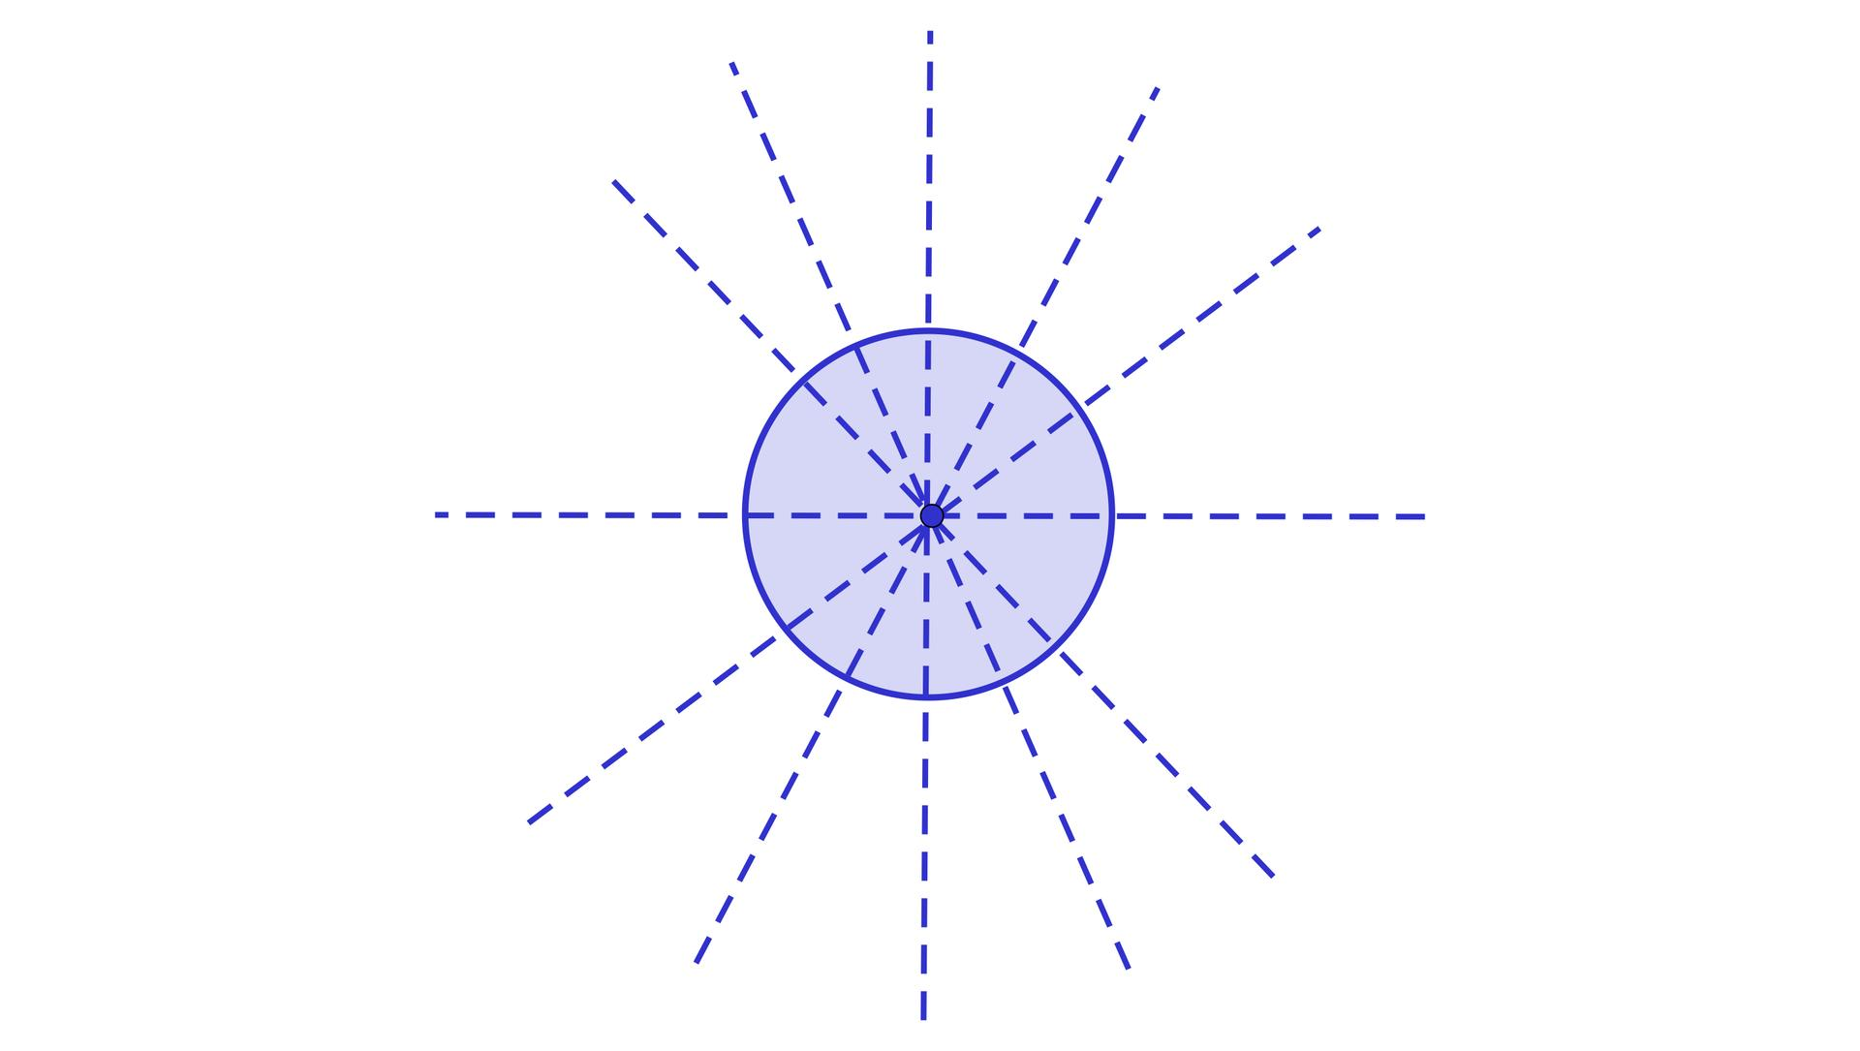
For example:
$${45}^{∘}, {90}^{∘}, {120}^{∘}, {180}^{∘}$$
and many other angles all leave a circle unchanged.

Rotational Symmetry of Common Figures
# Source: AI Source: Provided by: [Data Path: Persons Table -> ID Column: 1, Name_En Column: Motasem Essam] -> From: [ChatGPT] on [7/25/2026]
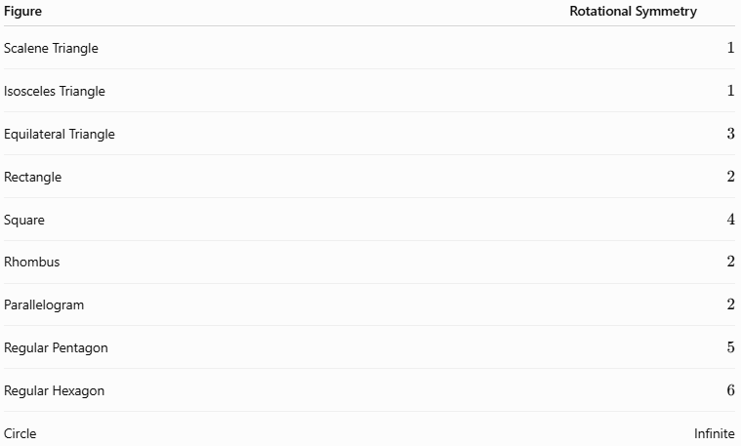
Figure | Rotational Symmetry
Scalene Triangle | $$1$$
Isosceles Triangle | $$1$$
Equilateral Triangle | $$3$$
Rectangle | $$2$$
Square | $$4$$
Rhombus | $$2$$
Parallelogram | $$2$$
Regular Pentagon | $$5$$
Regular Hexagon | $$6$$
Circle | Infinite
Important: An order of $1$ means that the figure only matches itself after the full ${360}^{∘}$ rotation; it has no non-trivial rotational symmetry.

Rotational Symmetry and (360^\circ)
# Source: AI Source: Provided by: [Data Path: Persons Table -> ID Column: 1, Name_En Column: Motasem Essam] -> From: [ChatGPT] on [7/25/2026]
A complete rotation is:
$$\boxed{{360}^{∘}}$$
If a figure has rotational symmetry of order $n$, the matching positions are separated by:
$$\frac{{360}^{∘}}{n}$$
For a square:
$$\frac{{360}^{∘}}{4}={90}^{∘}$$
The matching positions occur at:
$$0^{∘}, {90}^{∘}, {180}^{∘}, {270}^{∘}$$
The ${360}^{∘}$ position is the starting position again.

Rotational Symmetry and Congruence
# Source: AI Source: Provided by: [Data Path: Persons Table -> ID Column: 1, Name_En Column: Motasem Essam] -> From: [ChatGPT] on [7/25/2026]
Rotation is a rigid transformation.
Therefore, when a figure is rotated:
- Its size does not change.
- Its shape does not change.
- Its side lengths remain equal.
- Its angle measures remain equal.
- Its area remains unchanged.
Thus, the rotated figure is congruent to the original:
$$\boxed{\text{Original}≅\text{Rotated Image}}$$
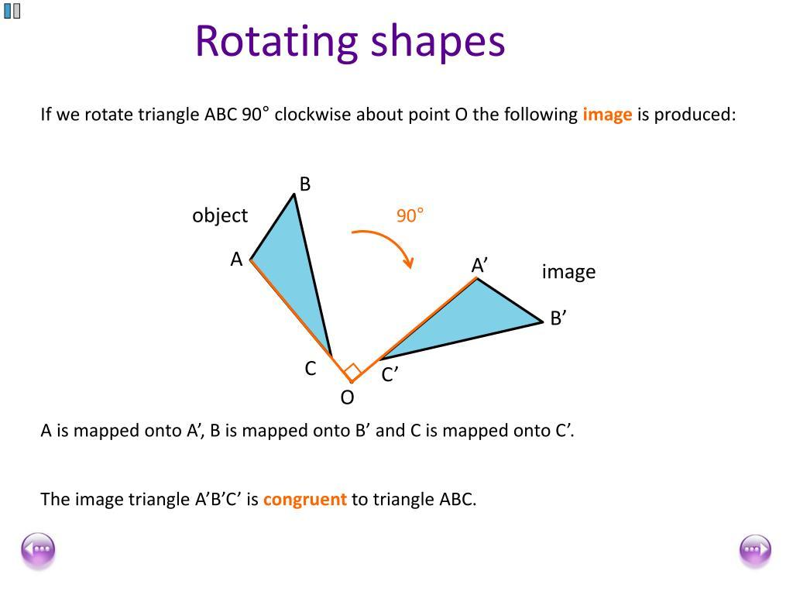
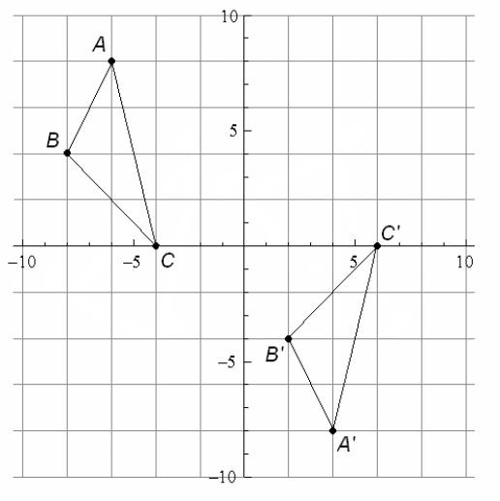
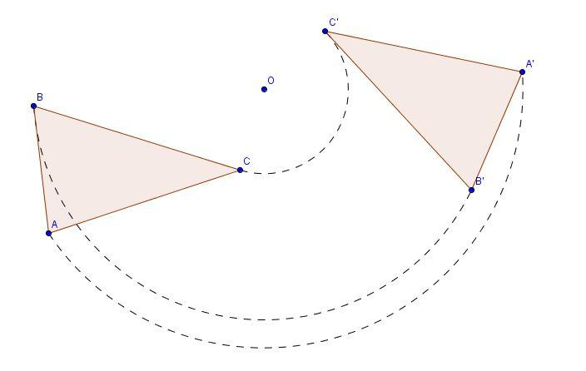
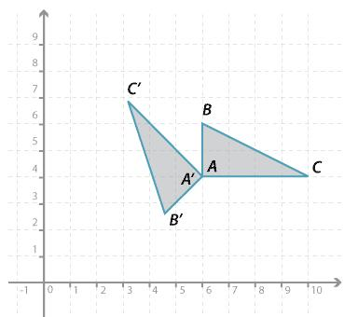
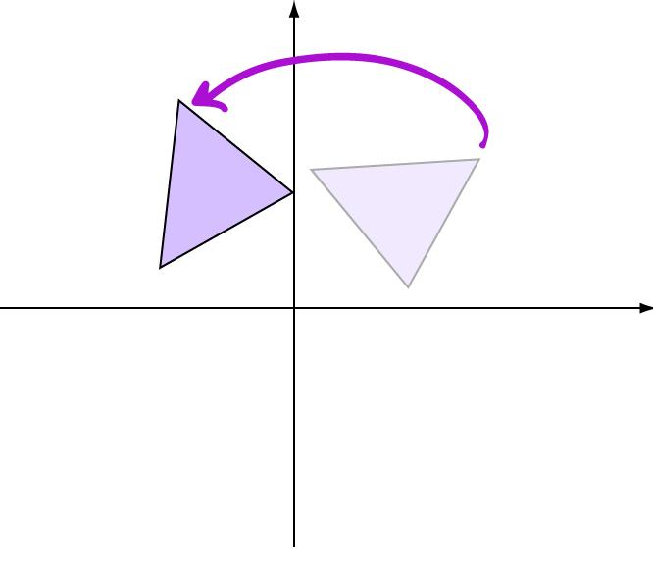

Rotational Symmetry and Line Symmetry
# Source: AI Source: Provided by: [Data Path: Persons Table -> ID Column: 1, Name_En Column: Motasem Essam] -> From: [ChatGPT] on [7/25/2026]
A figure can have:
- Line symmetry only.
- Rotational symmetry only.
- Both.
- Neither.
For example:
Square
A square has:
$$4$$
lines of symmetry and rotational symmetry of order:
$$4$$
General Parallelogram
A general parallelogram has:
$$0$$
lines of symmetry but rotational symmetry of order:
$$2$$
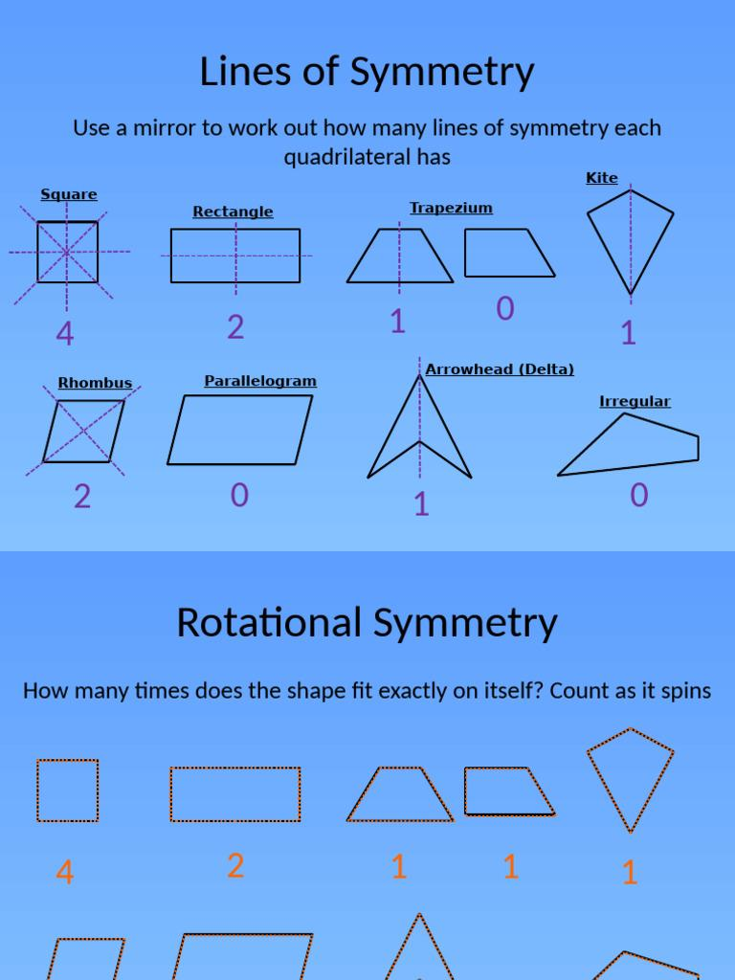
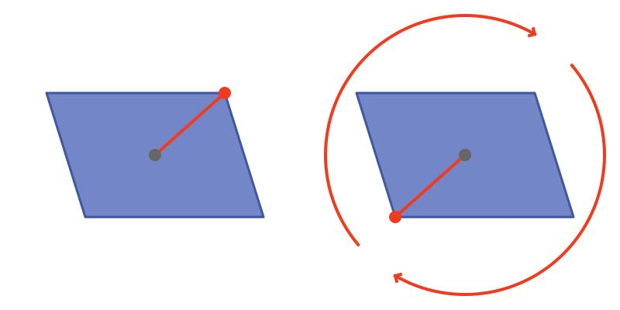
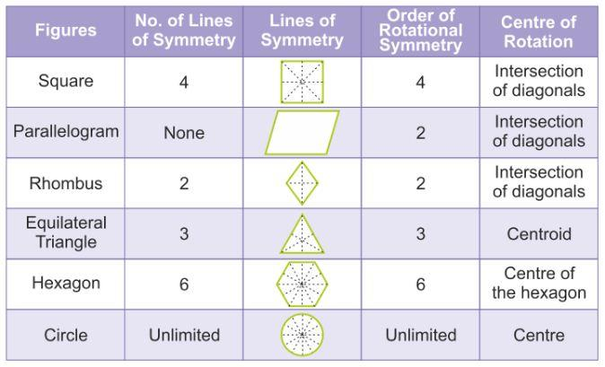
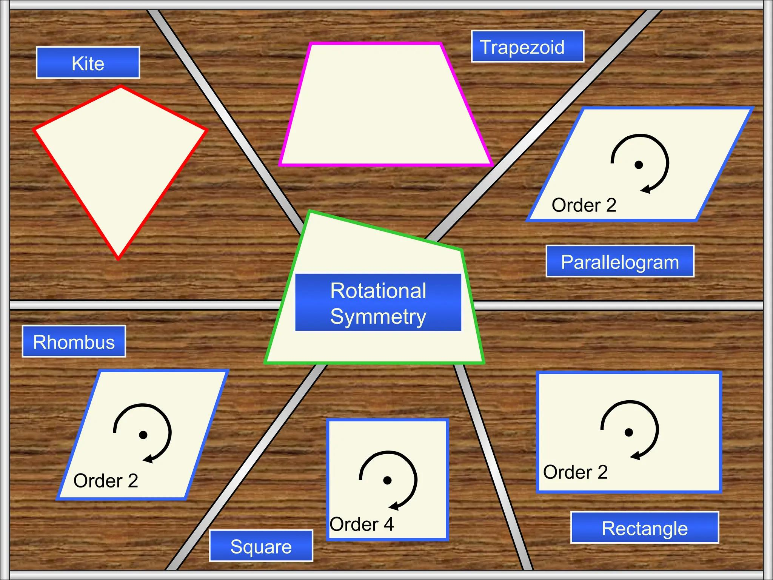
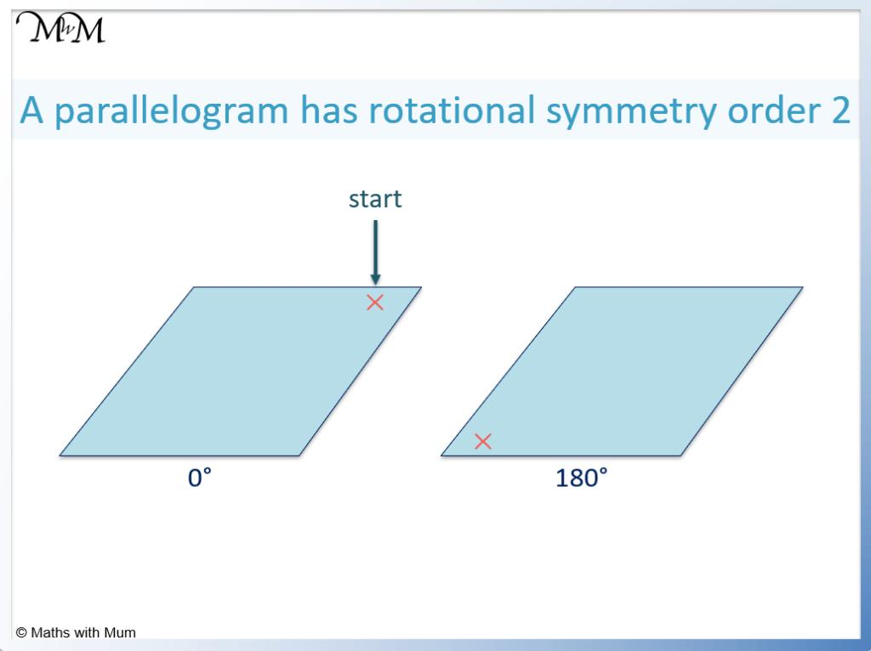

Point Symmetry
# Source: AI Source: Provided by: [Data Path: Persons Table -> ID Column: 1, Name_En Column: Motasem Essam] -> From: [ChatGPT] on [7/25/2026]
Point symmetry is a special case of rotational symmetry.
A figure has point symmetry if it maps onto itself after a:
$$\boxed{{180}^{∘}}$$
rotation.
Therefore:
$$\boxed{\text{Point Symmetry}=\text{Rotational Symmetry of }{180}^{∘}}$$
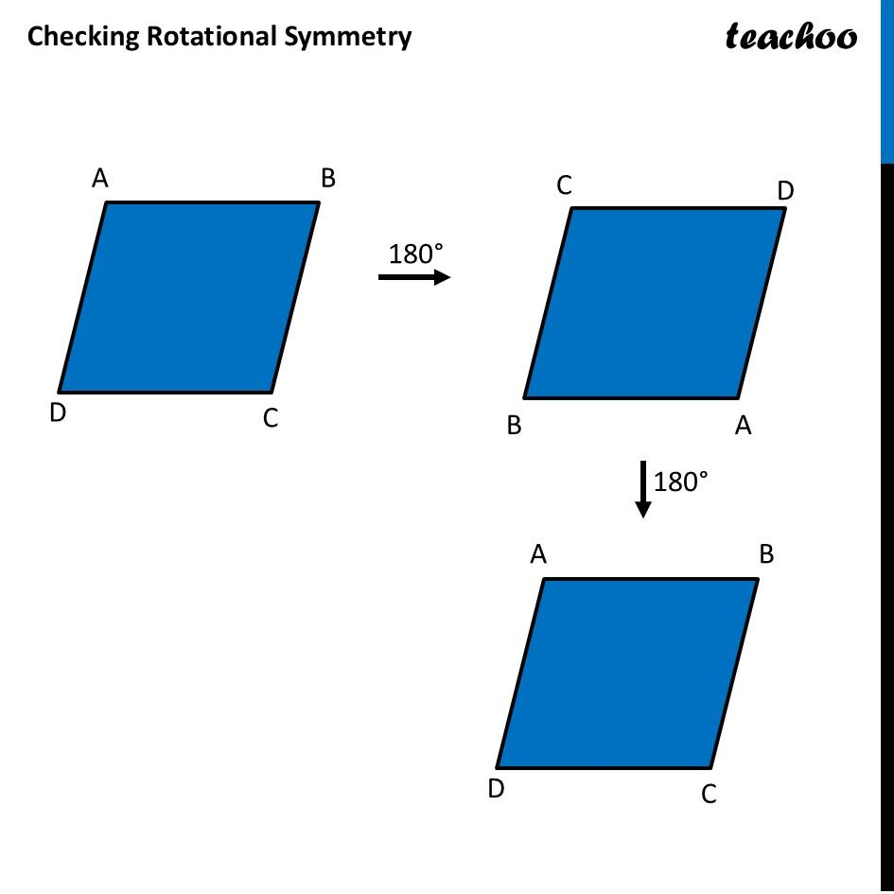
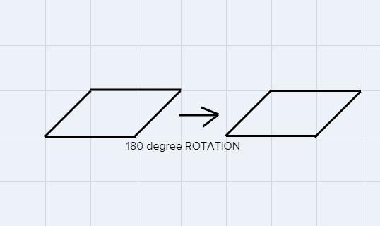
A figure with rotational symmetry of order (2) has a (180^\circ) rotational symmetry.

Coordinate Geometry
# Source: AI Source: Provided by: [Data Path: Persons Table -> ID Column: 1, Name_En Column: Motasem Essam] -> From: [ChatGPT] on [7/25/2026]
Rotational symmetry can also be studied using coordinates.
For a ${180}^{∘}$ rotation about the origin:
$$\boxed{\left(x,y\right)→\left(-x,-y\right)}$$
For a ${90}^{∘}$ counterclockwise rotation:
$$\boxed{\left(x,y\right)→\left(-y,x\right)}$$
For a ${270}^{∘}$ counterclockwise rotation:
$$\boxed{\left(x,y\right)→\left(y,-x\right)}$$
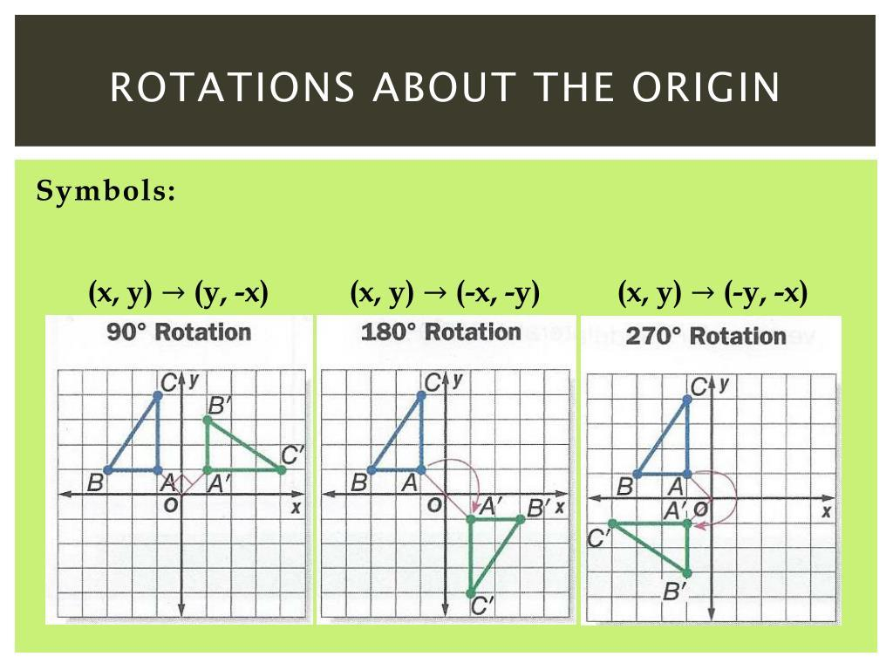
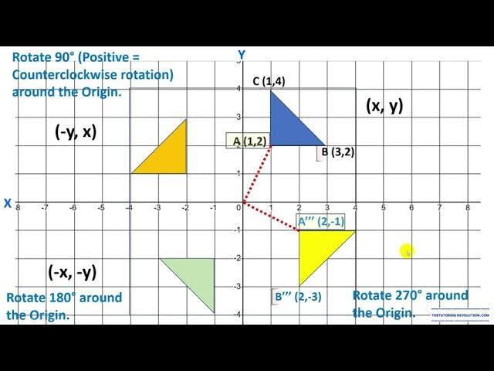
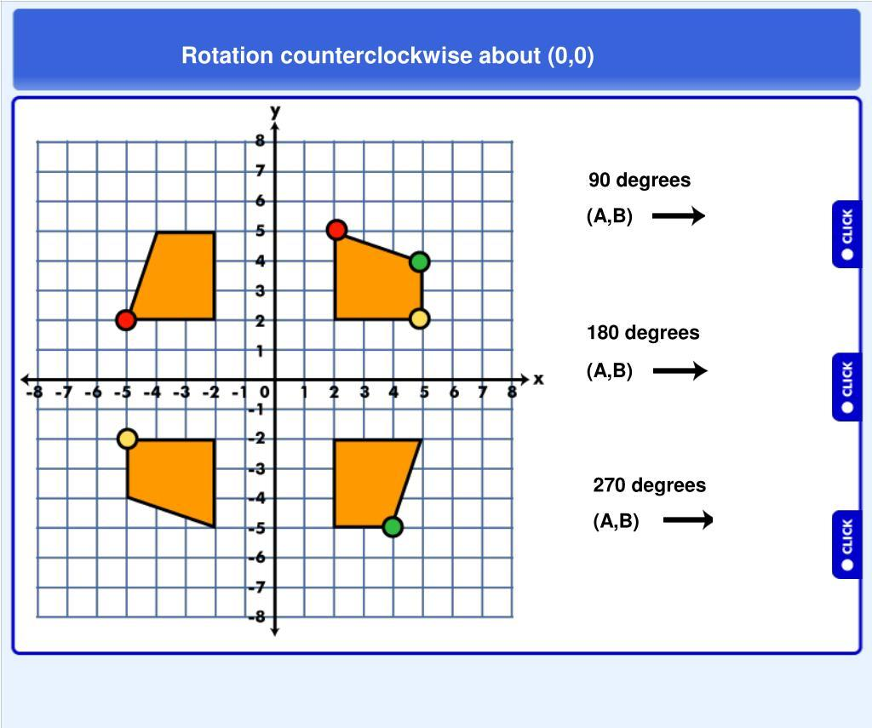
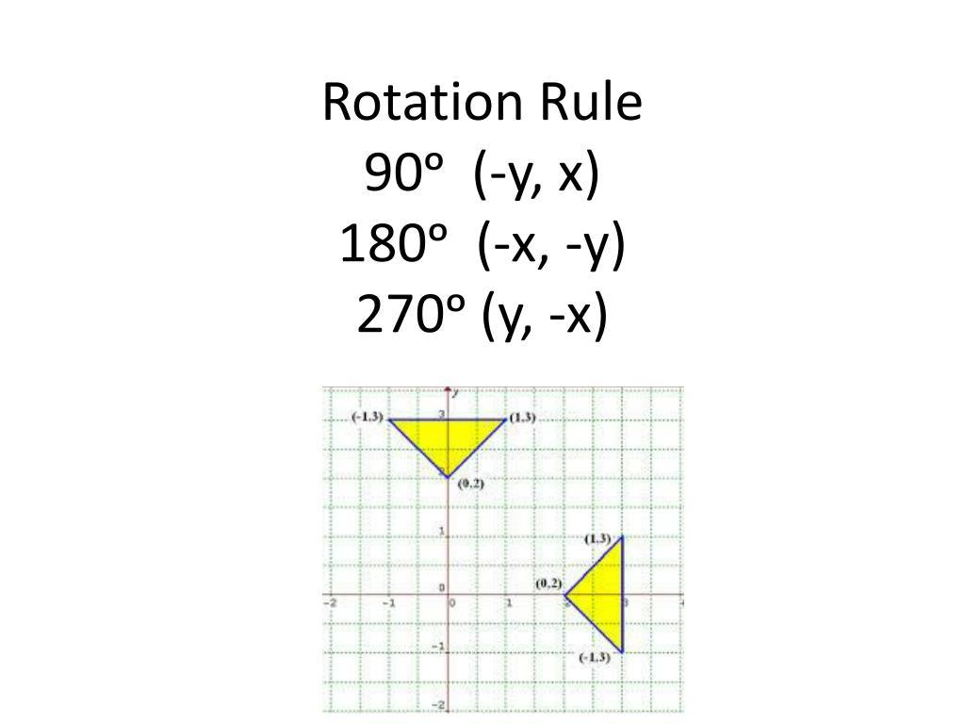
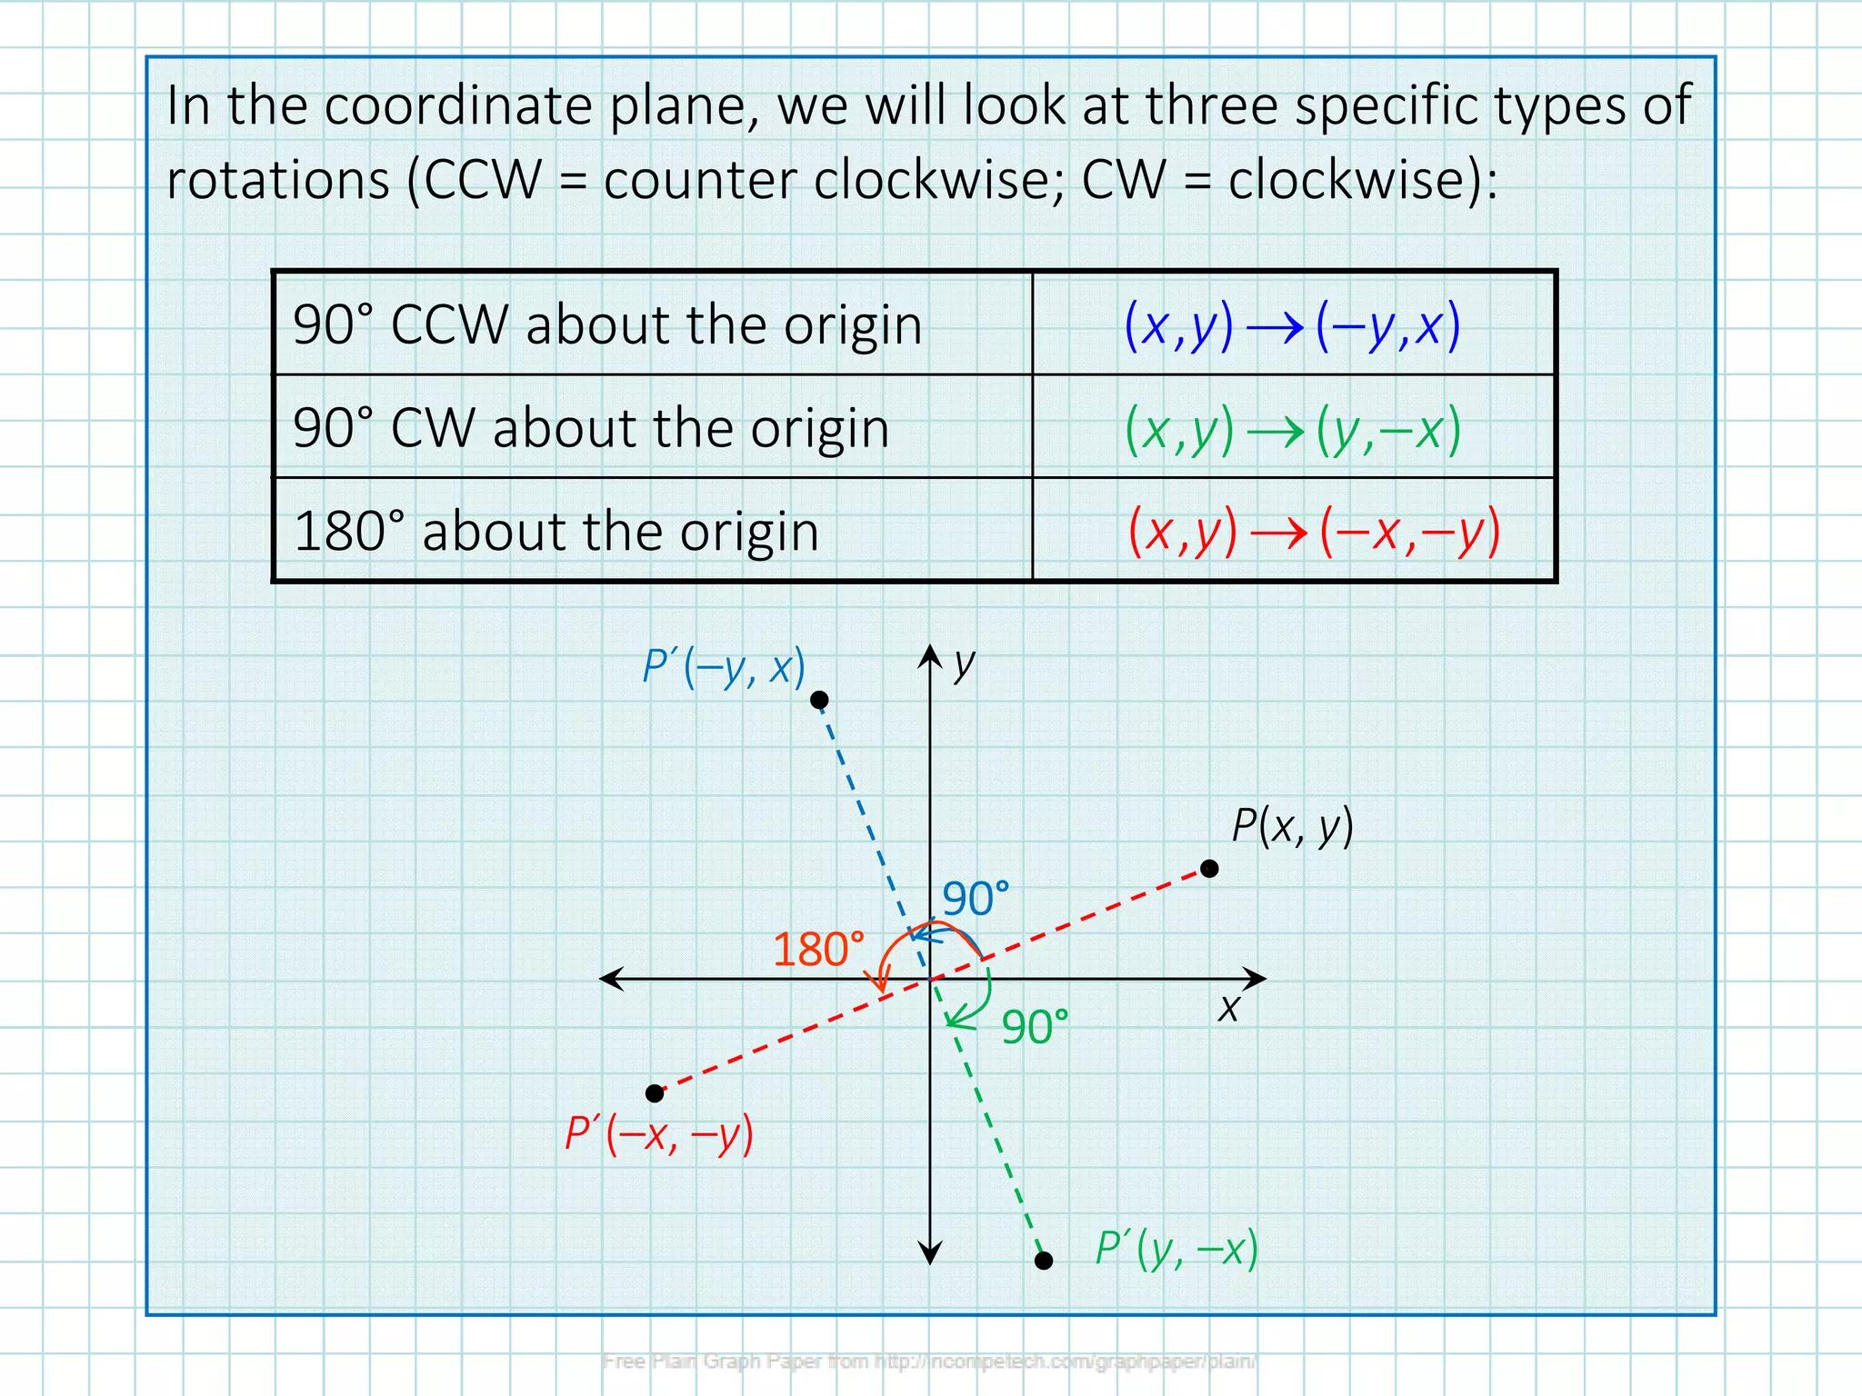

Rotational Symmetry in Nature
# Source: AI Source: Provided by: [Data Path: Persons Table -> ID Column: 1, Name_En Column: Motasem Essam] -> From: [ChatGPT] on [7/25/2026]
Rotational symmetry can be found in many natural structures.
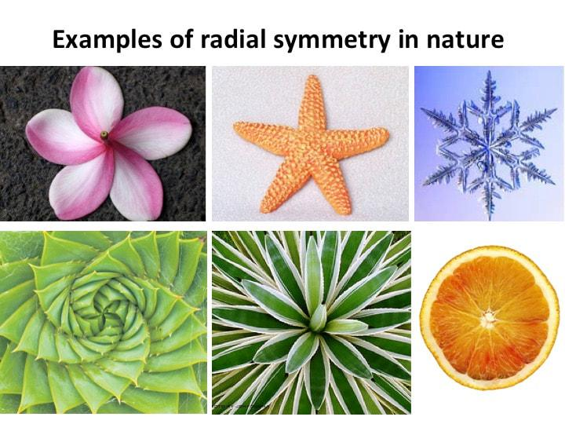
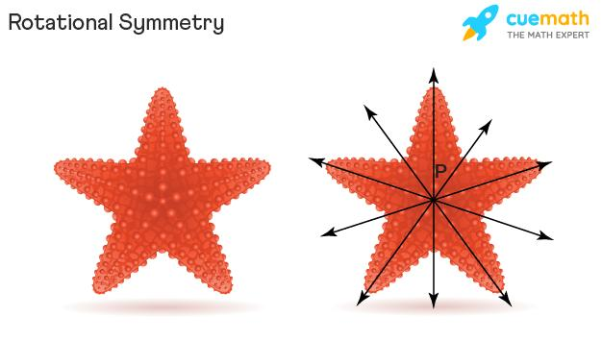
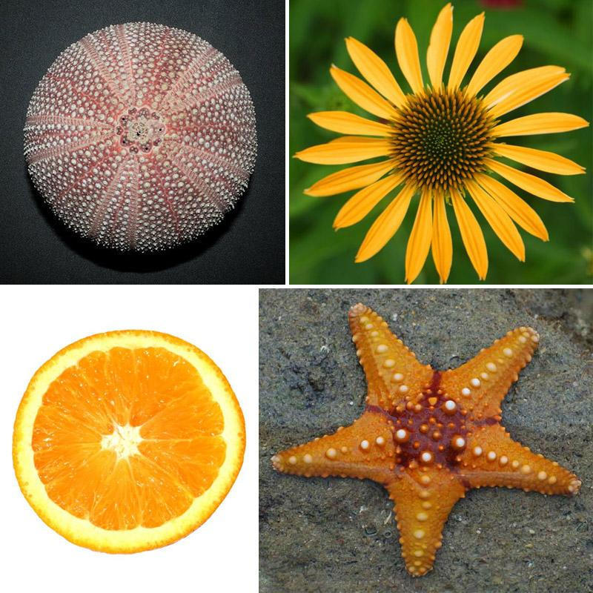
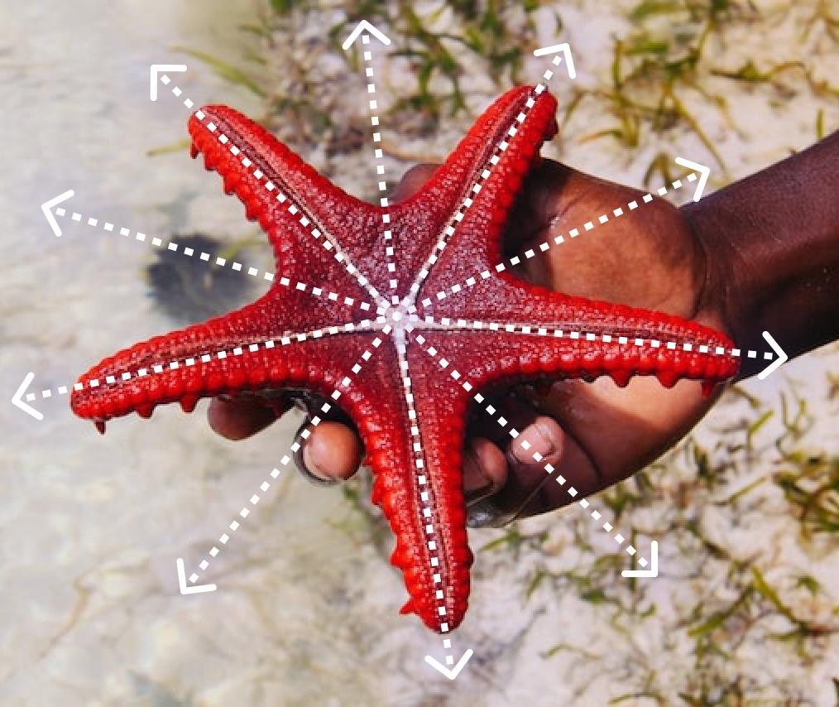
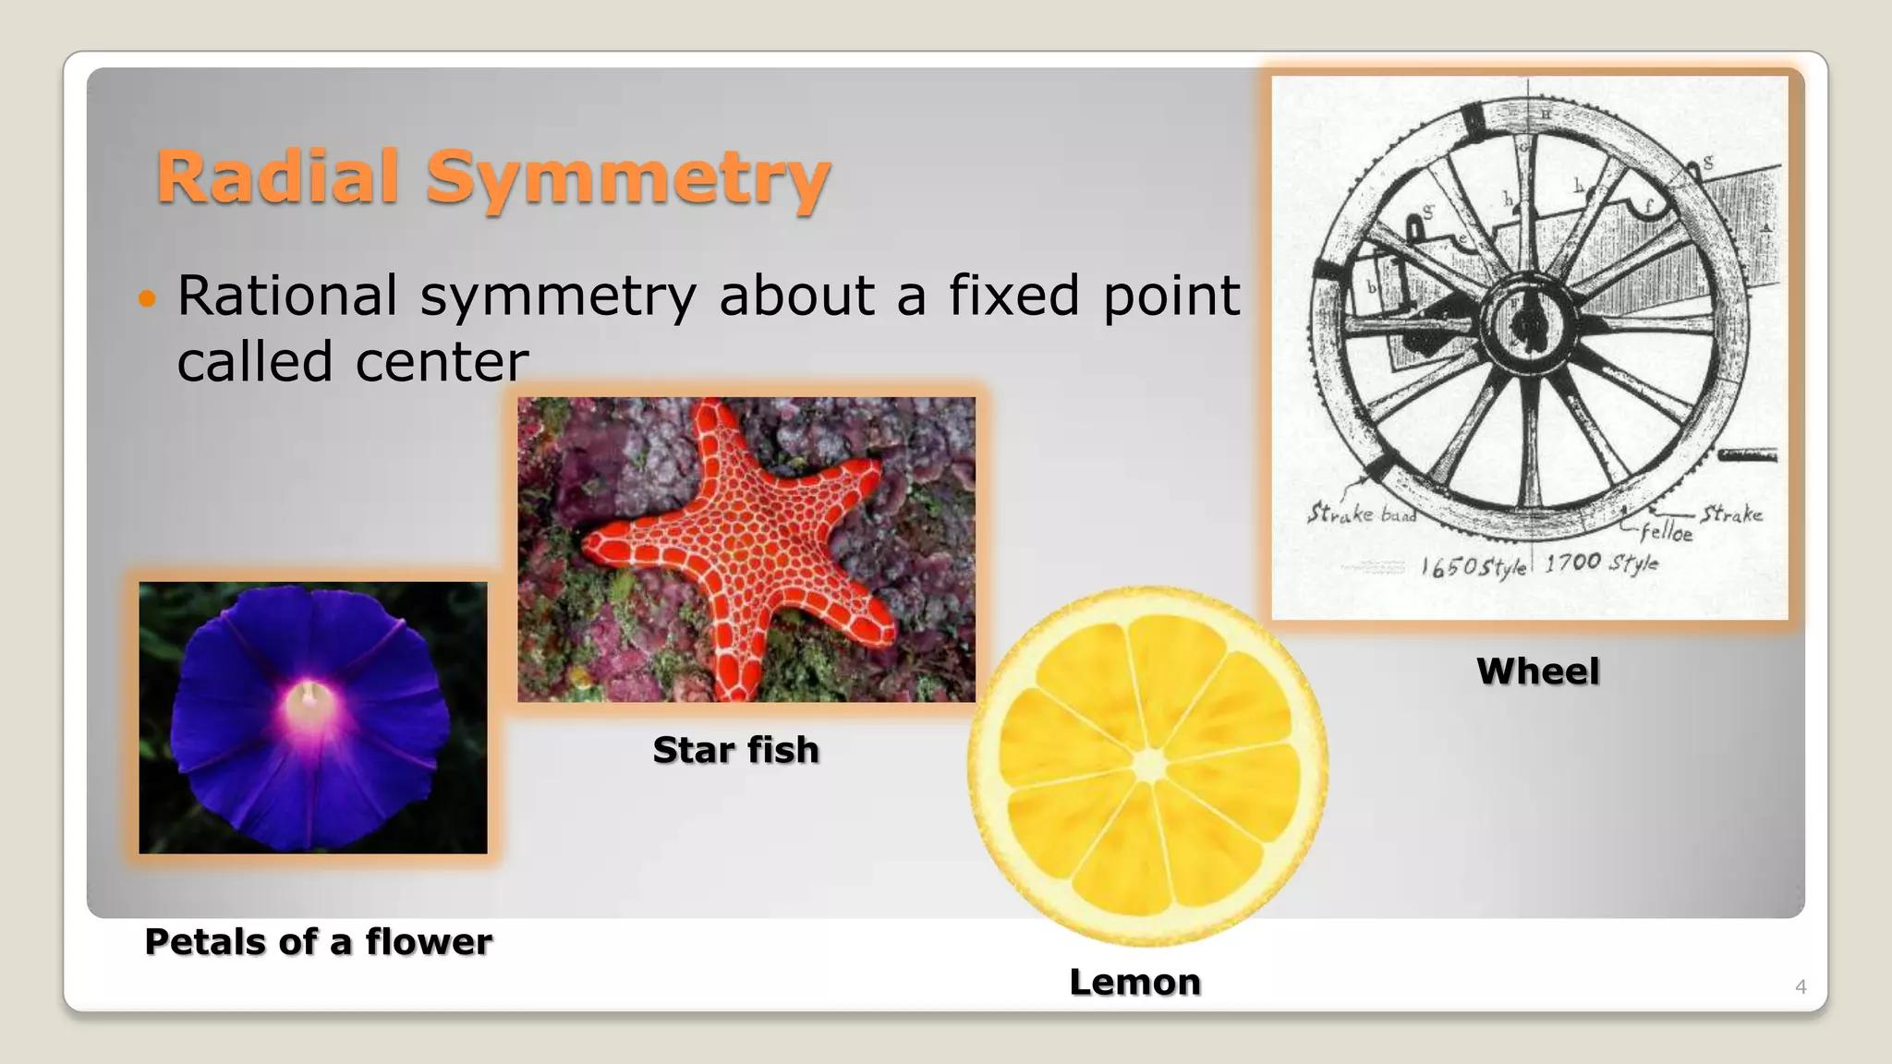
Examples include:
- Flowers.
- Starfish.
- Snowflakes.
- Some fruits.
- Some marine organisms.
- Crystal structures.
Natural objects may have approximate rather than perfect mathematical symmetry.

Rotational Symmetry in Architecture and Design
# Source: AI Source: Provided by: [Data Path: Persons Table -> ID Column: 1, Name_En Column: Motasem Essam] -> From: [ChatGPT] on [7/25/2026]
Rotational symmetry is frequently used in patterns and structures.
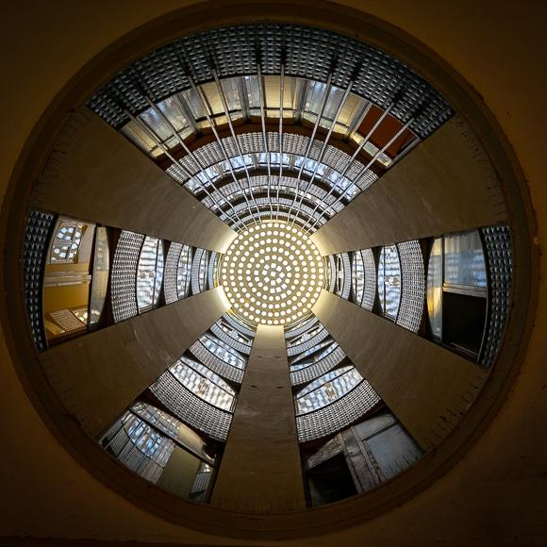
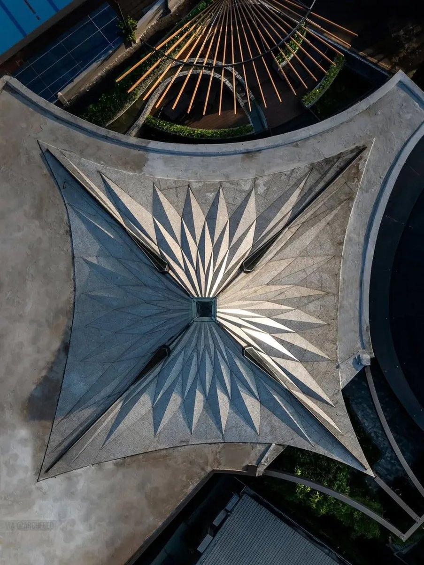
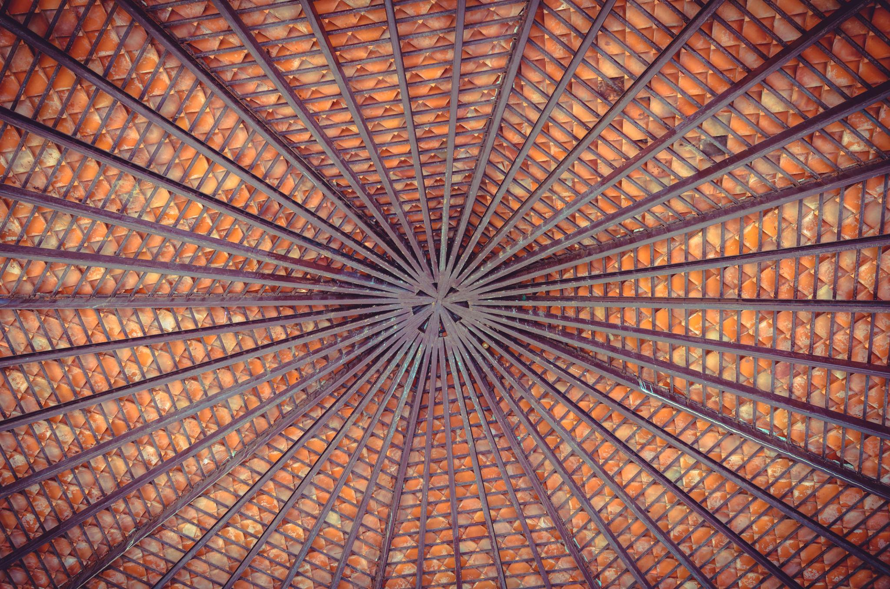

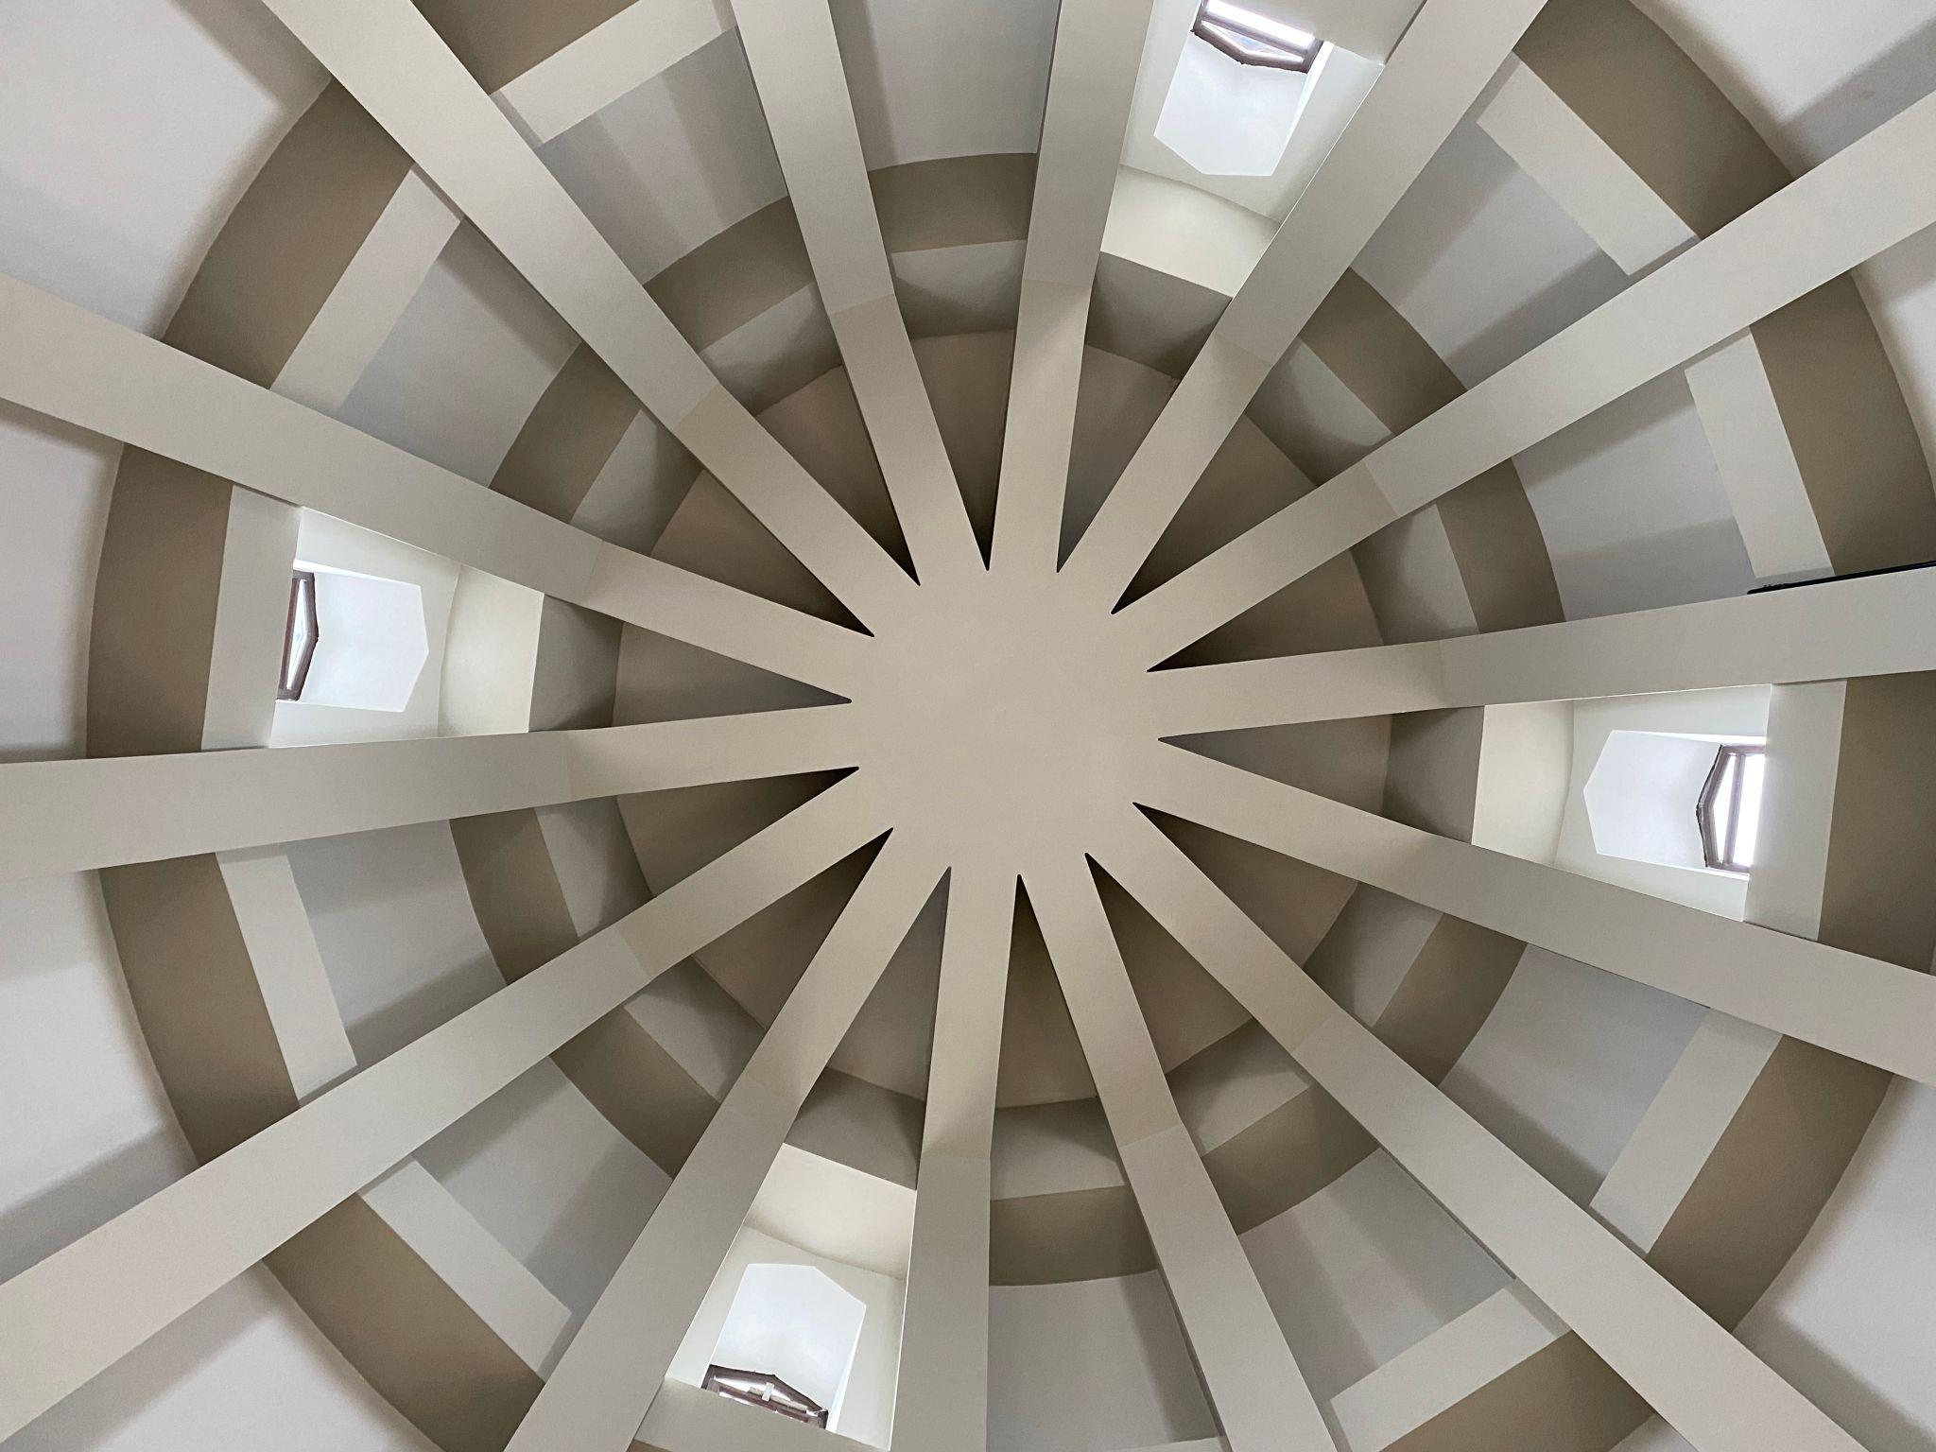
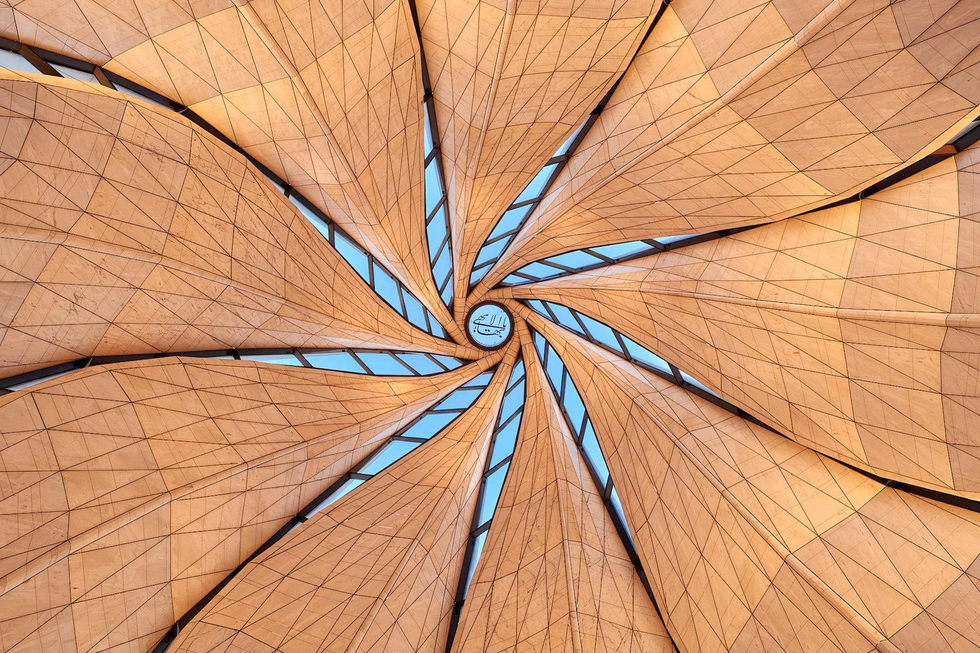

Examples include:
- Circular buildings.
- Domes.
- Decorative floors.
- Tiles.
- Mandalas.
- Wheels.
- Rotational patterns.
- Mechanical components.

Rotational Symmetry in Engineering
# Source: AI Source: Provided by: [Data Path: Persons Table -> ID Column: 1, Name_En Column: Motasem Essam] -> From: [ChatGPT] on [7/25/2026]
Many mechanical objects are designed around rotational symmetry.
Examples include:
- Gears.
- Wheels.
- Turbines.
- Fans.
- Rotors.
- Propellers.
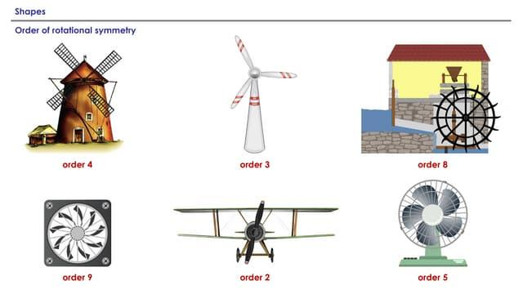
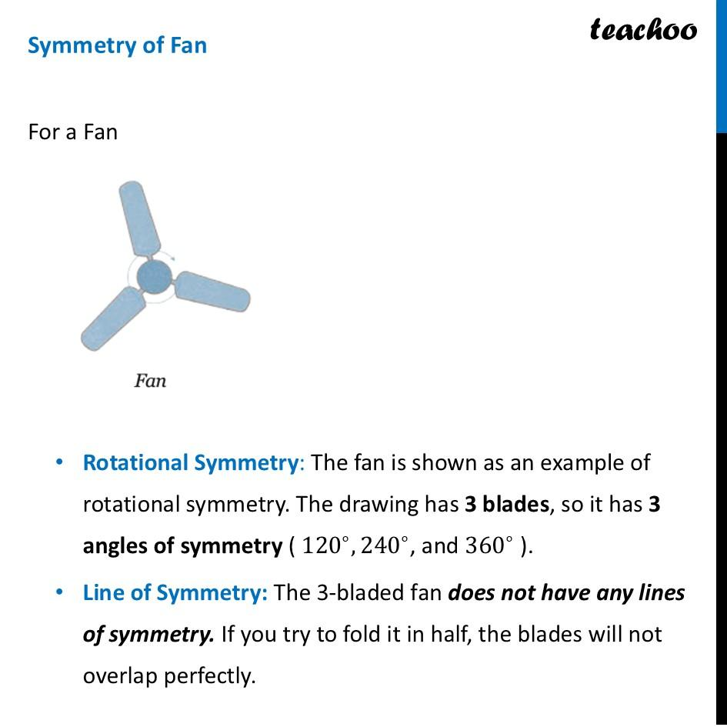
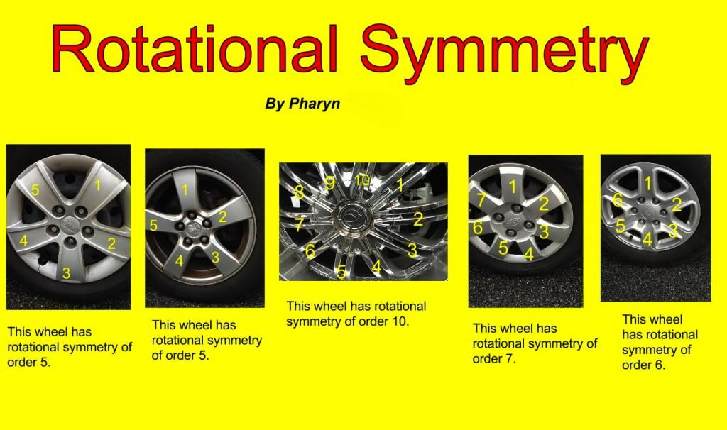
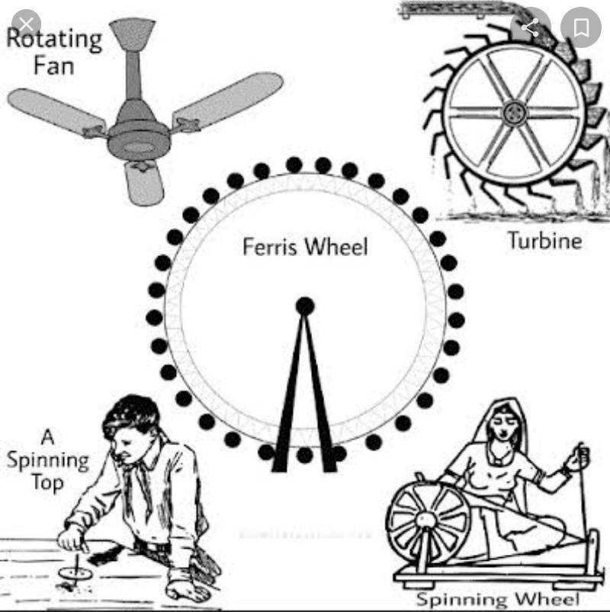
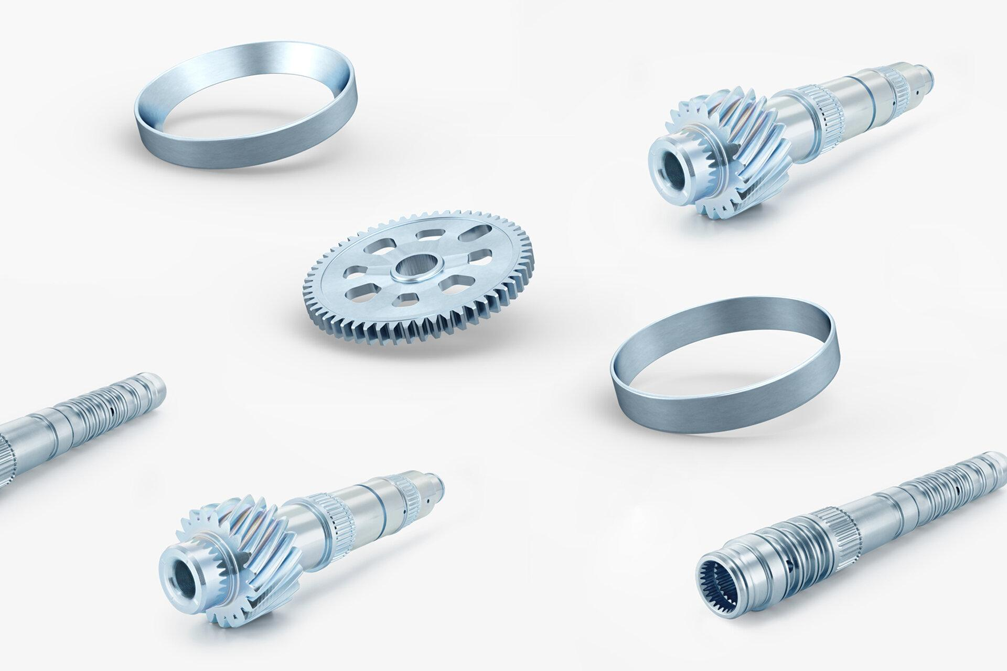
Rotational symmetry can make objects balanced around a central axis.

Rotational Symmetry in Computer Graphics
# Source: AI Source: Provided by: [Data Path: Persons Table -> ID Column: 1, Name_En Column: Motasem Essam] -> From: [ChatGPT] on [7/25/2026]
Rotational symmetry is used to create repeated structures efficiently.
For example, a designer can create one component and rotate it repeatedly around a center.
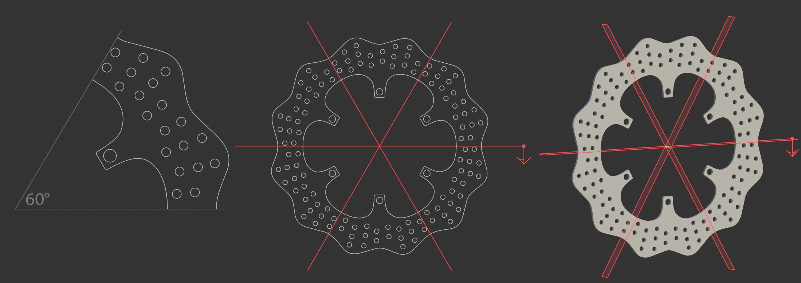
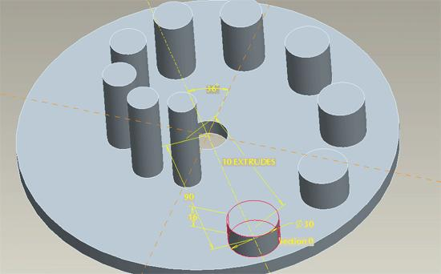
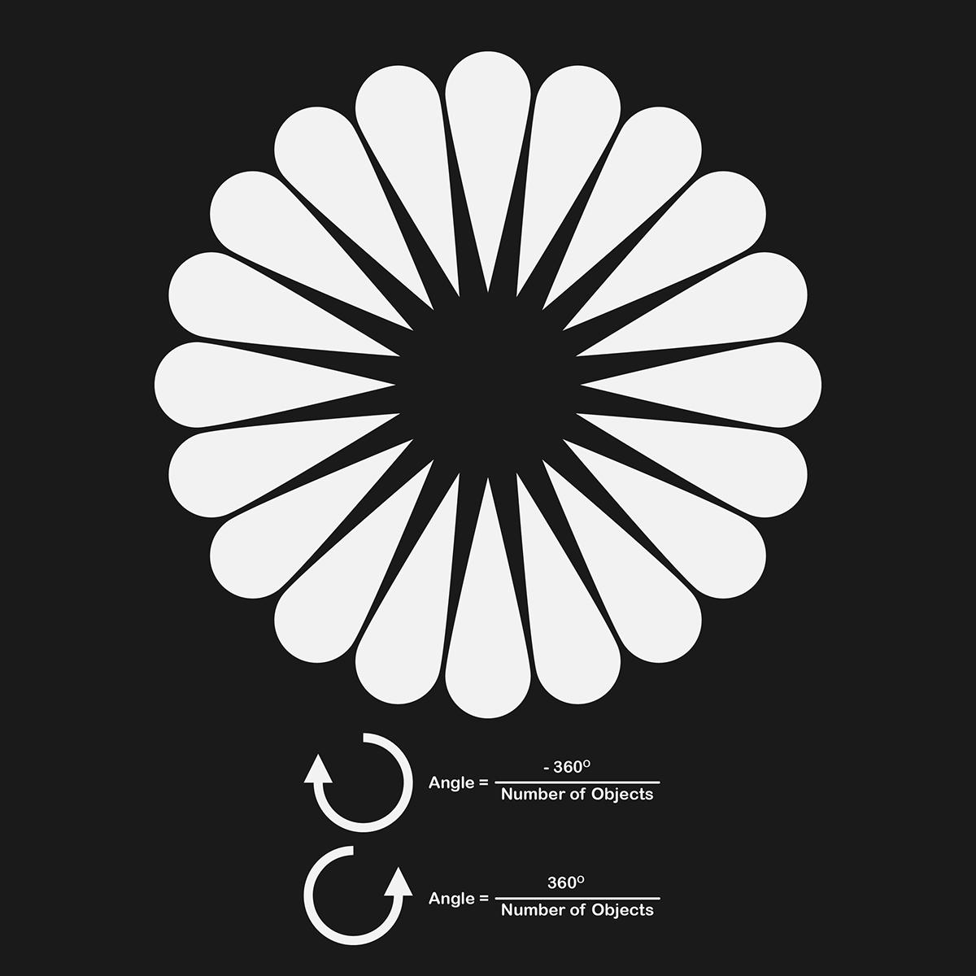
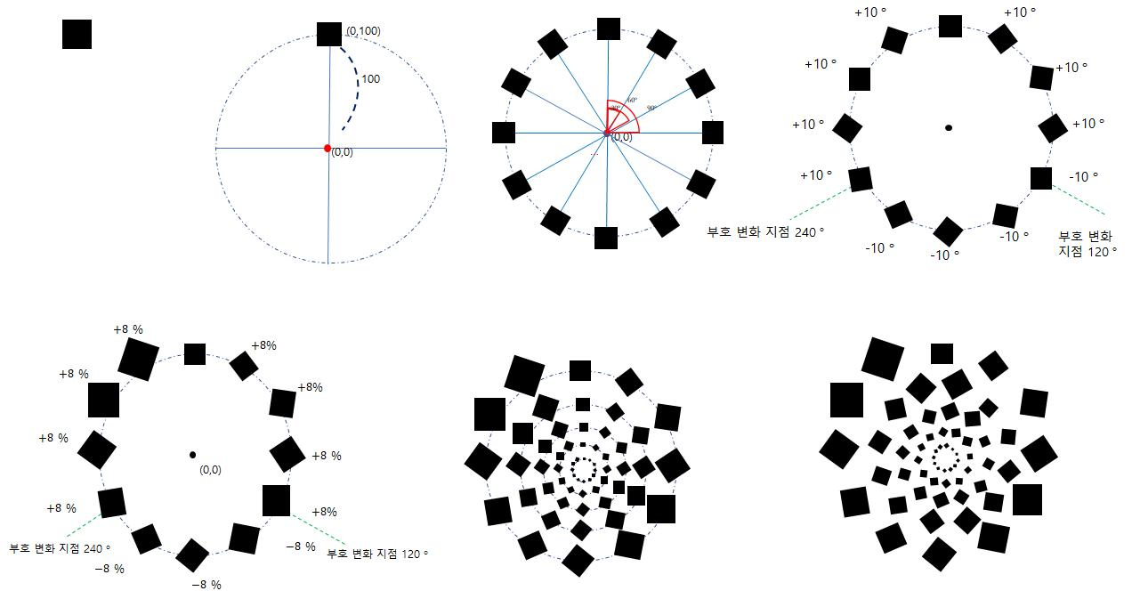
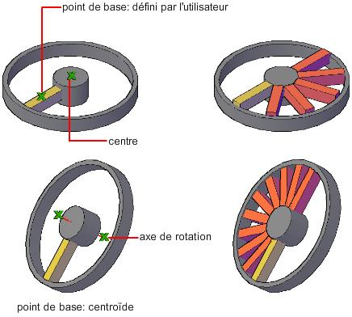
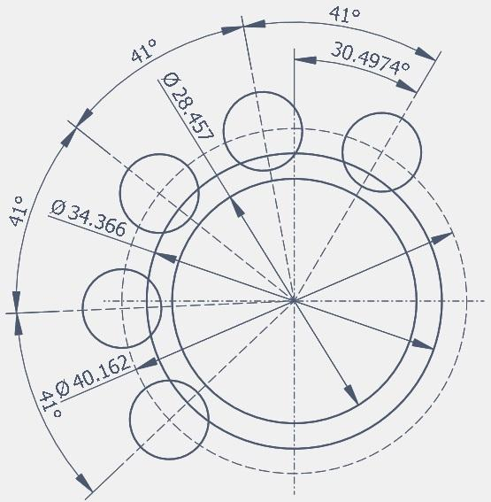
This is useful for:
- CAD.
- 3D modeling.
- Game development.
- Computer graphics.
- Product design.
- Animation.

Applications
# Source: AI Source: Provided by: [Data Path: Persons Table -> ID Column: 1, Name_En Column: Motasem Essam] -> From: [ChatGPT] on [7/25/2026]
Rotational symmetry is important in:
- Plane Geometry
- Geometric Transformations
- Coordinate Geometry
- Architecture
- Engineering
- Mechanical Design
- CAD
- Computer Graphics
- Product Design
- Art
- Pattern Design
- Crystallography

Advantages
# Source: AI Source: Provided by: [Data Path: Persons Table -> ID Column: 1, Name_En Column: Motasem Essam] -> From: [ChatGPT] on [7/25/2026]
Studying rotational symmetry helps to:
- Identify repeated geometric patterns.
- Understand rotation.
- Determine the order of symmetry.
- Calculate rotation angles.
- Analyze regular polygons.
- Understand point symmetry.
- Design balanced mechanical components.
- Create efficient geometric patterns.
- Develop spatial reasoning.

Limitations
# Source: AI Source: Provided by: [Data Path: Persons Table -> ID Column: 1, Name_En Column: Motasem Essam] -> From: [ChatGPT] on [7/25/2026]
Rotational symmetry:
- Does not exist in every figure.
- May be absent in irregular shapes.
- Requires a fixed center of rotation.
- Can be difficult to identify in complex figures.
- Natural and manufactured objects may only approximately exhibit rotational symmetry.
- Rotational symmetry alone does not imply line symmetry.

Comparison with Related Concepts
# Source: AI Source: Provided by: [Data Path: Persons Table -> ID Column: 1, Name_En Column: Motasem Essam] -> From: [ChatGPT] on [7/25/2026]
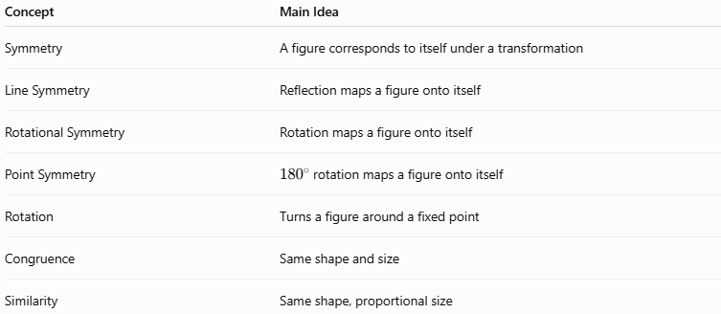
Concept | Main Idea
Symmetry | A figure corresponds to itself under a transformation
Line Symmetry | Reflection maps a figure onto itself
Rotational Symmetry | Rotation maps a figure onto itself
Point Symmetry | ${180}^{∘}$ rotation maps a figure onto itself
Rotation | Turns a figure around a fixed point
Congruence | Same shape and size
Similarity | Same shape, proportional size

Key Points
# Source: AI Source: Provided by: [Data Path: Persons Table -> ID Column: 1, Name_En Column: Motasem Essam] -> From: [ChatGPT] on [7/25/2026]
- Rotational Symmetry occurs when a figure matches itself after rotation.
- The fixed point is called the center of rotation.
- The order of rotational symmetry is the number of times the figure matches itself during ${360}^{∘}$.
- The smallest angle of rotation is:
$$\boxed{θ=\frac{{360}^{∘}}{n}}$$
- A regular polygon with $n$ sides has rotational symmetry of order:
$$\boxed{n}$$
- A circle has infinitely many rotational symmetries.
- Rotational symmetry of order $2$ corresponds to ${180}^{∘}$ rotational symmetry and is associated with point symmetry.
- Rotation is a rigid transformation, so the rotated figure is congruent to the original.
- Rotational symmetry is widely used in geometry, engineering, architecture, CAD, computer graphics, and design.

Conclusion
# Source: AI Source: Provided by: [Data Path: Persons Table -> ID Column: 1, Name_En Column: Motasem Essam] -> From: [ChatGPT] on [7/25/2026]
Rotational Symmetry is a type of Geometric Symmetry in which a figure coincides with itself after being rotated around a fixed center through one or more angles less than ${360}^{∘}$. The number of matching positions is called the order of rotational symmetry, and the smallest angle of rotation is calculated using $\frac{{360}^{∘}}{n}$. Regular polygons have rotational symmetry corresponding to their number of sides, while a circle has infinitely many rotational symmetries. Rotational symmetry is fundamental to geometric transformations, regular polygons, point symmetry, engineering, architecture, mechanical design, CAD, computer graphics, and pattern design.

